





Nepgears ecommerce website

DOCUMENTATION



NAME: **SUNIL THAPA**

STUDENT ID: **77181407**

SUBMISSIONDATE**: MAY 18TH, 2019**

WORDCOUNT**: 9181**

Table of Contents

ACKNOWLEDGEMENT 2

ABSTRACT 3

1.0 INTRODUCTION 4

1.1 Introduction 4

1.2 Aim of the System 5

1.3 Scope of the System 5

1.4 Benefits of the System 5

2.0 LITERATURE REVIEW 6

2.1 Review of Literature 6

2.1 Online Research 8

3.0 TECHNOLOGY REVIEW 13

3.1 Visual Studio 13

3.2 Xampp 14

3.3 PhpMyAdmin 15

3.4 QSEE Superlite 15

3.5 Microsoft Project 2010 15

3.6 Bootstrap 15

3.7 AdminLte 15

3.8 HTML5 16

3.9 CSS3 16

3.10 Morris.Js 16

4.0 METHODOLOGY 17

4.1 Agile System Development Life Cycle (SDLC) 17

Initiation 17

Planning 17

Design 18

Implementation 18

Testing 18

5.0 REQUIREMENTS GATHERING AND ANALYSIS 19

5.1 Requirement Analysis 19

5.1.1 Application Requirements 19

5.1.2 Hardware Requirements 19

5.1.3 Functional Requirements 19

5.1.4 Non-functional Requirements 20

6.0 PRODUCT DEVELOPMENT 21

6.1 Entity-Relationship Diagram (ERD) 21

6.2 Use Case Diagram 22

6.2.1 Admin Use Case Diagram 22

6.2.2 Customre/User Use Case Diagram 23

6.3 Database Design 24

6.3 Data Dictionary 25

6.4 Front End Website 29

6.5 Back End Website 34

7.0 PRODUCT TESTING 40

7.1 Unit Testing 40

7.2 Integration Testing 40

7.3 System Testing 41

7.4 Test Cases 41

8.0 PRODUCT EVALUATION 44

9.0 PROJECT EVALUATION 45

10.0 CONCLUSION 47

11.0 BIBLIOGRAPHY 48

12.0 APPENDICES ✔ 50

# ACKNOWLEDGEMENT

It is my privilege on expressing gratitude of thanks to my Project Supervisor, Mr. Saroj Kafle, who have helped on my research process and successfully complete my final project for graduation. I thank him for his whole hearted support, encouragement, corporation and also constructive criticism throughout the process of the completion of the project.

I deeply thank Our IT Program Leader, Mr. Arun Lal Joshi, for his guidance and support during the research project and leading towards the better result of the project.

I also take this opportunity to thank my lecturers at British College, who has directly and indirectly helped me in my research project. I like to thank My Classmates, for their positive support and encouragement during the project.

# ABSTRACT

The report describes the development of a "Nepgears Ecommerce website ". The report opens with an overview of research of different literature and technology undertaken to build the product. It continues to describe the advantages of agile model over other software development model chosen to develop the project. And the bulk of the report goes on to describe different stages of a software development lifecycle: designing, implementation and testing, and evaluation. The report continues to summarize the project development process and focuses on the importance of using proper project management techniques and discusses future changes that could be implemented in the product.

# 1.0 INTRODUCTION

## 1.1 Introduction

Ecommerce is still in its infancy in Nepal. The country’s challenging terrain and lack of street addresses make deliveries a challenge. Credit card transfers and transfers from e-banking websites are sometimes accepted, but Nepalese who do not have a dollar account cannot make payments using foreign currency. Government law, not to allow international money transfer through online for consumers intensifies the problem even more.

There are a handful of websites that offer ecommerce for consumers in the Kathmandu Valley, although most of these are traditional retailers that offer delivery services for their products ordered online. An online food delivery website (www.foodmandu.com) is popular with both expatriates and local residents. Sastodeal and Daraz are rising online shopping portals ([www.sastodeal.com](http://www.sastodeal.com) , [www.daraz.com](http://www.daraz.com)).

Although ecommerce is a multi-billion dollar business internationally, it is less popular in a developing country like Nepal. Don’t confuse with the fact that ecommerce actually growing in Nepal as well but with a slower pace. People will still prefer local store instead of online shopping due to few reasons. Firstly, they have trust issues of actually getting the product and even if they get it, they doubt it is genuine product. Secondly, due to poor delivery services. Once I order an earphone and it took 3 days to reach me which bothered me a lot.

“Nepgears” is an online store that is designed to serve gamers here in Kathmandu, Nepal. It is a website created by me to actually run this website and sell gaming products online. I am to target specific group of people in our community that is gamers. This idea came to my mind when I was trying to build a gaming pc and I did not get the products I wanted neither online nor offline (In Stores). I then thought of importing products from china and sell it in Kathmandu.

The proposed system (web application or website) has the full functionality to fulfil the requirements of customers as well as admin. This website also generates sales reports of different times for admins. Customers can search, browse and add products to a cart and also pay with PayPal (Online payment gateway). Two modes of payment is supported by our website that is PayPal and cash of delivery.

Furthermore, each user have their own dashboard and could access and upload information according to the user privilege for example, Admins can add, view and edit orders, products, mange users and so on. Whereas customers can only view their invoice and edit their user details.

## 1.2 Aim of the System

The main aim of our system is to provide platform for customers to buy products online.

## 1.3 Scope of the System

The final product will be a full-functional ecommerce website. The website will allow users to search and add items to their cart, it will then require to sign up to checkout and complete order. This system will give users best experience in shopping online.

Some of the additional features of the proposed system are as follows:

* Rating and review can be given by customers
* Account login for different users
* Search engine to search products

By adding these features, the website will be more interactive so that the user who view the website gets all the information and it would be easy for them to plan which product to buy. Also, by making the website fully functional help to attract more users to view the website and gain popularity of the website.

Future Planning

* Google map integration to locate address and deliver to that location
* Implementation of ONLINE customer service

## 1.4 Benefits of the System

The developed system is very useful because it is easier to search and order products online rather than going to the local stores. Prices can be compared easily and products can be ordered easily. Products will be delivered to your doorstep at a reasonable time so it also saves a lot of time for customers.

# 2.0 LITERATURE REVIEW

## 2.1 Review of Literature

This section of the report contains all the literatures that were researched for the research topic of the report that is research on selling high end or expensive gaming products in Nepal. The explanations in this section range from researches performed to find out about the history of ecommerce and gaming industries in worldwide context. Because of scarce data obtained in terms of Nepalese gaming industry, comparative studies have been done and conclusions have been made based on worldwide studies and an online research has been performed which will discussed in next section.

The global e-commerce payment market accounted for US$ 24.26 Billion 2017 and is expected to grow at a Compound annual growth rate (CAGR) of 13.1% over the forecast period 2018-2025, to account for US$ 64.69 Billion 2025. The demand for e-commerce payment is largely influenced by a number of factors such as availability of several online payment options on e-commerce websites such as e-wallet, debit & credit cards, net banking etc. Increasing banking population worldwide and rising smartphone adoption coupled with increasing internet penetration. Furthermore, the growth of cross-border e-commerce provides a potential opportunity for the e-commerce market (Dublin, 2018).

Amazon, a leading online store with a market value of $777.8 billion. Amazon is the poster child for the entire industry, leading us into a very bright ecommerce future. Even with Amazon grabbing 4% of all retail sales in 2017 and projected to account for 50% of the U.S. ecommerce retail market by 2021, both Amazon and the ecommerce industry in general are still poised for massive growth. The potential growth for global ecommerce is astounding. In 2017, nearly 1.66 billion people worldwide purchase products online, amounting to 2.3 trillion U.S. dollars. But it doesn’t stop there. Projections show a growth of up to 4.48 trillion U.S. dollars by 2021. One of the reasons that this trend is only just getting started is because younger generations prefer online shopping to traditional stores (Peters 2019).

Computer games’ influence is growing continuingly as research shows that the age of children playing games continue to be younger and internet usage among children becomes more popular. Moreover, the internet access has become widespread since 1990s, which impacted people’s working, socializing and behaviors (Dindar & Akbulut, 2014). The Internet become an important media role in information age especially for children and youth who are a group that influences by internet use (Makesrithongkum, 2009). The internet also has a great impact on marketing concepts especially in the game sectors in terms of alerting relationship marketing activities with customers (Maklan & Klaus, 2011).

Online games become interactive because they allow game players around the world to interact with each other in one single platform. Eventually, online games began to becoming the important factor of our social culture (Nuangjumnonga & Mitomo, 2012) and (Williams et al., 2008). Online games also bring people together to form society which players interact with each other in virtual world that are always on. These worlds, called “massively multiplayer online games” or MMOs (Steinkuehler & Williams, 2006).

As the computers and online games market grew rapidly many people especially teenager spend great amounts of time playing online games (Boyle, Connolly, & Hainey, 2011; González-González, Toledo-Delgado, Collazos-Ordoñez, & González-Sánchez, 2014). Challenges for marketing industry in measurement of online game players’ interaction with a game become critical since it is an important key for company sustainability (Tony, Richard, & Paul, 2009). Moreover, there is a few knowledge about how customer experiences on online game that would be from their consumption which might be interpreted into customer value perception (Iyanna, Bosangit, & Mohd-Any, 2012).

## 2.1 Online Research

The report has so far covered information which are related to ecommerce and international gaming industry. But the research project has been created so as to cater Nepalese gaming industry and community. This would of course require relevant facts and Information related to the target local Industry but there were a lot of limitations that were encountered when trying to fetch data related to that target Nepalese gaming market. No credible data was found regarding Nepalese gaming industry so it was difficult to proceed with the planned method of research.

As an alternative, online research was devised to be implemented. To gather information which would be usable for developing an online store, plans were first made on how to conduct effective research. I came to conclusion that I must do an online survey so that I can get more data and be accurate. Being myself a pro gamer, I had a good fan base and gaming community members. I spread the message that I am opening an online store for gaming products in Nepal. They were all very excited, and they did took part in online survey. I got almost 100 responses from my friends and colleagues. Substantial data was obtained from the questionnaire which has been presented below:

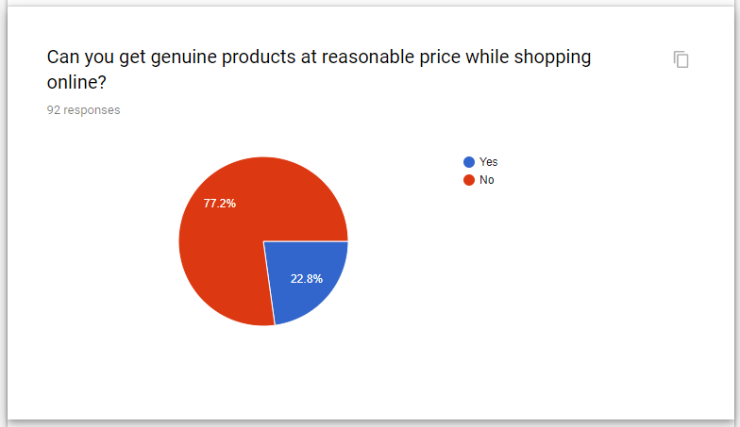

The main aim of this question is to know whether people believe that they are getting a genuine product at a reasonable price point. But this result dominates the fact that they cannot get good products at reasonable price.

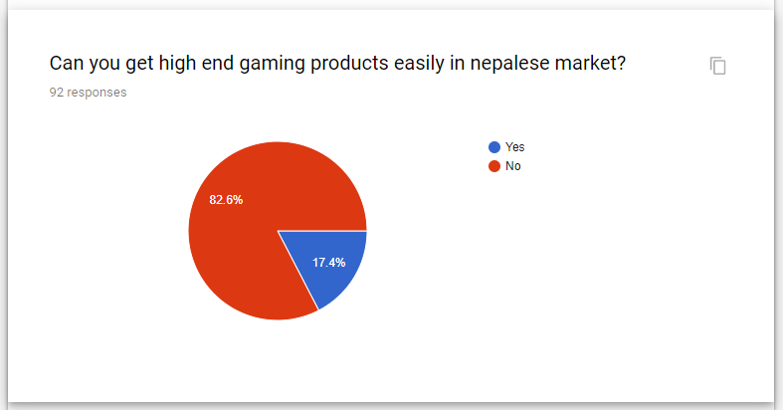

The main target of this question is to know that people are getting the products of their choice or has wide variety of products available in Nepalese market. But more than 80% of them believes that they cannot get the gaming products easily in Nepal.

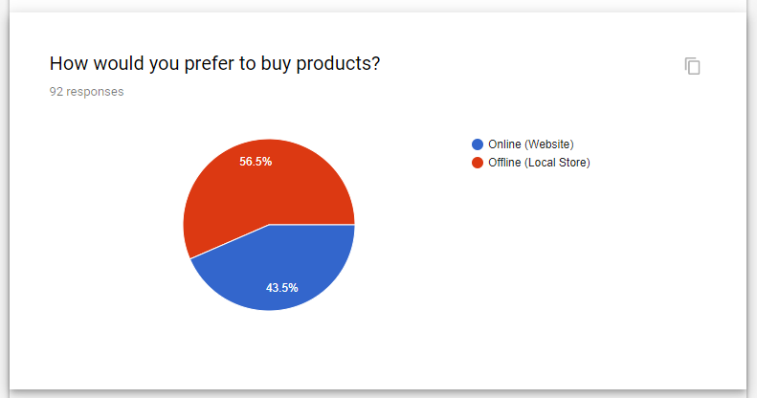

This question is asked to check whether people will choose to buy products online or at offline market. I have had a dominant feeling that most of them will choose online market, but the result is opposite here. Majority of them would prefer to buy products offline. This result signifies the lack of trust on online market, so there is a lot to improve to gain more trust in online market.

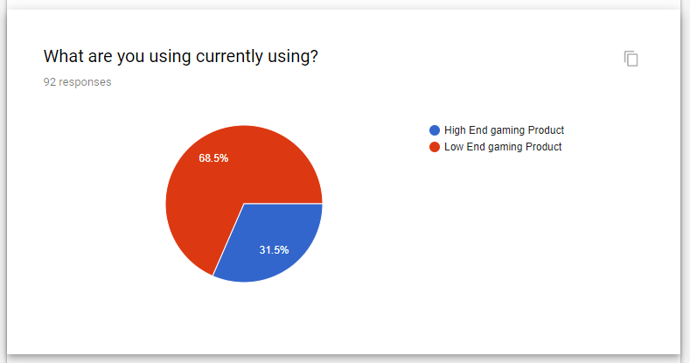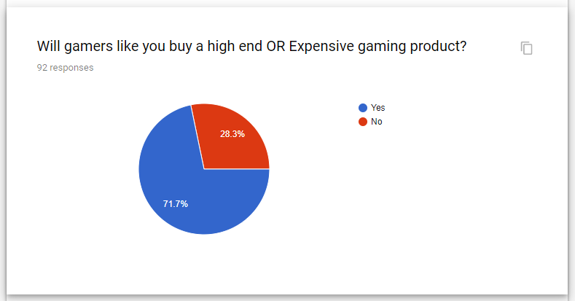The main aim of this project is to sell high end gaming products in Nepal. That is why I asked this question, to have a good knowledge of gamers being interested in buy gaming products. This result suggest maximum number of gamers will buy a high end gaming gears to match their needs in gaming.

This question has a sole purpose of getting idea of what gamers are currently using while playing games. This result shows that most of them are using low end products for gaming. This suggest that there is a huge market chance for an expensive one and that is the sole purpose of this research.

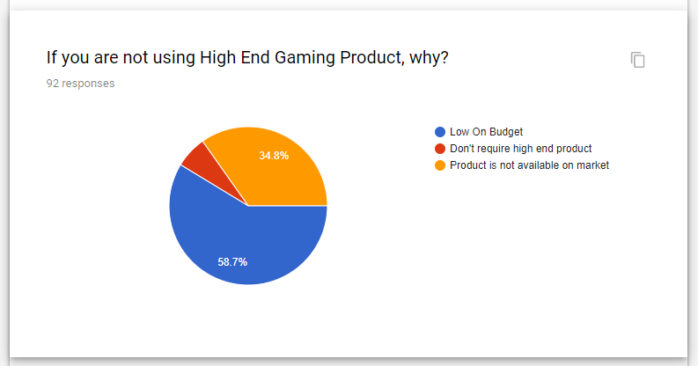

This question is asked to know why gamers are using low end products for gaming. This result shows that most of them are low on budget to buy expensive gaming products. However, almost 35% of them are actually interested in buying high end gaming products but due to lack of products of their choice in Nepalese market, they are not buying it.

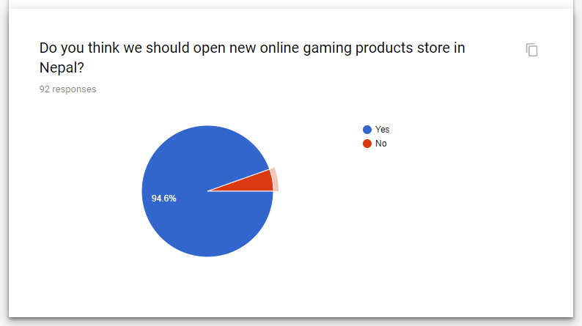

This question is asked for their suggestion for me to open a gaming products store. Almost everyone suggested to open that store in Nepal.

From the research data above, we can conclude following things. First, people are arguing that they get genuine product at a reasonable price. Second, people cannot get products of their choice in Nepalese market. Third, it is kind of 50-50 on buying products online or offline. Fourth, they are currently using low end products but they will definitely buy a high end gaming products for gaming on future. Fifth, around 60% of them are low on budget but 35% of them are actually willing to buy gaming product but most of them are not getting products they want in Nepalese market. Sixth, there is huge market potential for high end gaming products.

From the above gathered data, it was easy for me to come to a conclusion that I should definitely open a gaming products store. This research helped me a lot in finalizing my decision of opening a store. Thus, this website was designed and will soon be implemented.

# 3.0 TECHNOLOGY REVIEW

While making any product, the product must be made in the strong establishment and ought to be planned concerning the business objectives with higher ease and with best choices. The suitable decisions of technology limit expenses and support prerequisites, and advance ease of use and extendibility of the product. Consequently, because of this reason, the required innovation should be picked with appropriate inspection and analysis. An extensive variety of instruments and technology are utilized while building up the purposed system.

Some of the tools and technologies that are used for developing the software are described below:

## 3.1 Visual Studio

Visual Studio is an integrated development environment developed by Microsoft. It allows developing desktop app for windows as well as web sites, web apps and mobile apps. It enables to write code accurately and efficiently without losing the current file context. It includes IntelliSense i.e. code completion for functions, methods. It also supports author languages such as XML, CSS and JavaScript.

Since Visual Studio supports most of the things needed, the project was done in ASP.NET MVC which is a part of Microsoft. ASP.NET is an open source web framework for building web apps and web services. It allows creating website based on HTML5, CSS, and JavaScript. ASP.NET MVC allows creating powerful pattern based way to build web applications.

Visual Studio also includes a debugger that works as source-level debugger and machine-level debugger. It also includes numbers of designer such as Windows Forms Designer, WPF Designer, Class Designer, Data Designer etc. that aids in the development of the application. It also can run plugins that extends the features of Visual Studio. Source control system is also pre-built in the application. API can be found easily. It also helps navigating easily to the code and allows finding reference by grouping, filtering and searching function. A feature called Code Lens allows navigating to related function or finding who last modified a method without leaving the code.

It also has a feature which helps finding and fixing common coding issues live as you type the code from within the editor. It also has support for code refractor which helps in restructuring the code that was written earlier and extract method from within.

Visual Studio also comes with the .NET Framework uncluding Common Language Runtime. It supports different programming languages such as XML/XSLT, HTML, JavaScript and CSS. Support for other languages can also be added through language services installed separately.

## 3.2 Xampp

XAMPP is a free and open-source cross-platform web server solution stack package developed by Apache Friends, consisting mainly of the Apache HTTP Server, MariaDB database, and interpreters for scripts written in the PHP and Perl programming languages. Since most actual web server deployments use the same components as XAMPP, it makes transitioning from a local test server to a live server possible. XAMPP's ease of deployment means a WAMP or LAMP stack can be installed quickly and simply on an operating system by a developer. I also used it to host a database locally.

## 3.3 PhpMyAdmin

phpMyAdmin is a free software tool written in PHP, intended to handle the administration of MySQL over the Web. phpMyAdmin supports a wide range of operations on MySQL and MariaDB. Frequently used operations (managing databases, tables, columns, relations, indexes, users, permissions, etc) can be performed via the user interface, while you still have the ability to directly execute any SQL statement.

## 3.4 QSEE Superlite

QSEE Superlite is a universal forming environment, accomplished of supporting a large number of varied modelling tools. It is one of the best software to design various models for any software as it is easy to use and is more reliable and flexible. Here, I have used this software to design different diagrams like use case diagram, UML diagrams and so on. The main features of QSEE Superlite are inbuilt syntax rule, code generation from models and automatic constancy etc. ("QSEE Technologies | CASE And Modeling Tool Specialists - Leeds Beckett University").

## 3.5 Microsoft Project 2010

Microsoft Project 2010 offers influential, visually superior methods to effectively manage variety of projects with their emphasized stages and workflow. It is mostly developed to aid a project administrator in conveying resources to tasks, preparing a time line, following developments, managing the financial plan, and analyzing workloads for the specific project.

To track project status and timetables, it aids project manager for managing time tables, resources and budget allocation and work breakdown approach in Gantt chart.

## 3.6 Bootstrap

Bootstrap is one of the most used framework that consists of both the HTML5 and CSS3 elements that is an open source coding which was published in GitHub in 2011 by Twitter. It is very functional as it supports both recent and upcoming version of web browser like Google Chrome, Firefox, Opera, Torch, Microsoft Edge and so on.

## 3.7 AdminLte

AdminLTE is a popular open source WebApp template for admin dashboards and control panels. It is a responsive HTML template that is based on the CSS framework Bootstrap 3. It utilizes all of the Bootstrap components in its design and re-styles many commonly used plugins to create a consistent design that can be used as a user interface for backend applications. AdminLTE is based on a modular design, which allows it to be easily customized and built upon. This documentation will guide you through installing the template and exploring the various components that are bundled with the template.

## 3.8 HTML5

HTML5 is the basic framework of creating any website. It aims to improve the language that supports the latest technology while keeping it simple and easily understandable by humans, computers and devices. Simply, HTML5 is a mark-up language used to structure and present content on the World Wide Web (www).

## 3.9 CSS3

Cascading Style Sheet 3 (CSS3) is a style sheet that is used for describing the appearances and formatting of a documents like layouts, boarders, colours, fonts, backgrounds, text formatting etc. that are all written in the mark-up language. Thus, allowing the web application to display differently depending on the device the user is viewing the site.

## 3.10 Morris.Js

Morris is a pretty and powerful Charts Plugin with jQuery and Raphael JS Library to make drawing simple charts easy. With Morris.js, we can create a wide variety of charts like line & area charts, bar charts and donut charts to fit you needs. It also works fine on mobile device such as iOS and android. We have used line chart in our project to show some reports like sales and profit.

# 4.0 METHODOLOGY

To build any product a research must be done. Reviewing or analyzing the work done by other researchers related to the content. For this project, similar technique is adapted for developing the application. This section of the report explains about the type of development model used and hot it is relevant to this project.

## 4.1 Agile System Development Life Cycle (SDLC)

For this project agile model was followed. The agile model provides persuading of different projects uniquely and reviews the present methods to best-fit the requirements. The works are divided on the timely basis (completing some tasks periodically) and iterated after each build.

Agile uses an adaptive method of software development unlike waterfall model (traditional SDLC), it uses a predictive approach. Predictive in a sense the outcome or the features to be included is decided before hand and the work is executed accordingly. Below are the different steps or an approach used in the project.

### Initiation

To start with any project, the requirements should be studied. Thoughts and ideas for the project title was looked up and brainstormed. Any interesting topic or idea was collected and discussed with the supervisor if it was feasible to work on. After finalizing the title, the objectives of title and possible outcome of the project was discussed. Deciding on the title and the goals of the project helped to move on to the next step.

### Planning

An initial planning of the project was submitted to the supervisor. With this submission, the project can finally be started. To begin, research must be done relevant to the topic. So, related to the topic, the usage and the work done by other researchers were collected. The findings were not totally dependent on what others had done, but also on the features of the technologies that are used for the development of the project. Every once a week, supervisor meeting was conducted. In the meeting, the supervisor gave feedback on the initial report and progression. Changes in the report was done accordingly and continued with further progression of the project.

### Design

This phase includes the designing of the data flow diagram, database and UI of the application. This helps in developing the app in a step wise process with all the goals and objectives.

### Implementation

In this stage, all the development work of the application was carried out. First, a simple data scraper was designed to crawl the data from the share market website. The data would then be inserted into the database. To view the data, an interface was designed that also displays the data in chart format.

This stage of implementation required a lot of time. To design a data scraper, required a lot of researching to be done. There are many and powerful web scrapers available that could have been downloaded and made the work a lot easier. But, building a scraper from the scratch and helped me gain knowledge about the basic workings of the scrapers. There were also many errors while developing the application. Since building this application was new, debugging and figuring out the errors took time. After all the researching and debugging the application was finally ready for testing.

### Testing

Testing is usually considered as the end of a project. The application is tested using different types of test scenarios. Any errors found, depending on the type of test the will be debugged. In most cases the application is tasted using basic technique like white box testing and black box testing. The application was executed and returned no errors

# 5.0 REQUIREMENTS GATHERING AND ANALYSIS

It includes a full scale level investigation of the customer’s necessities. And furthermore includes characterizing optional answers for the customer’s necessities and cost-benefit advantage explanation of provided options. Thus, carrying out detailed study of the customer’s requirements and fulfilling exact requirements for the program to run. Simply, this stage includes solidifying the necessities before the planning the stage begins.

The requirements phase aims to come up with requirement specification documents so that the requirements are clear and detailed as possible. Generally, in order to assemble and gather the requirements, a committed group is arranged.

To decide the requirements involved, traditional methods is used such as collecting the information of each user, observation and study of documents and other systems which is simple, reliable and profitable however, they are only operative when the objectives of the project are clear as little or no risks are involved.

## 5.1 Requirement Analysis

System requirement specification is the initial point of developing any application. As the system gets more complex, it becomes plainer and the goal of entire system would be easily understood. Hence, the need for the requirement analysis phase was arose.

Requirements that are essential to run this web application are mentioned below.

### 5.1.1 Application Requirements

Only to run database, phpmyadmin is required otherwise any device can run our website.

### 5.1.2 Hardware Requirements

Any device with web browser is capable of running our website. So, there is not much hardware requirements.

### 5.1.3 Functional Requirements

Functional requirements defines all the actions or procedures taken place in the system. These are shared through interactions with the different users of the system.

In our website, there are two types of user that is admin and customer that utilize the information from the site. This website is designed so that user would be able to browse and order products. Thus, different users have their own control panel from where they could view and edit their information from the website.

Here, Admin have got full access to the system like add, update or delete users, products and so on. Simply saying, admin got all privileges on this website. Whereas, normal user (i.e. customer) have access to add products to cart, checkout, view and edit personal details. Similarly, user would be able to search any products available in the store.

### 5.1.4 Non-functional Requirements

Non-functional requirements is a one of the necessity for any website because it specifies standards which would be used to review the operation of any system, rather than specific actions. Hence, non-functional requirements are certainly essential in any type of website or system. There are several non-functional requirements such as dependability, usability, enhancement, ability to continue, security, accessibility and so on.

# 6.0 PRODUCT DEVELOPMENT

## 6.1 Entity-Relationship Diagram (ERD)

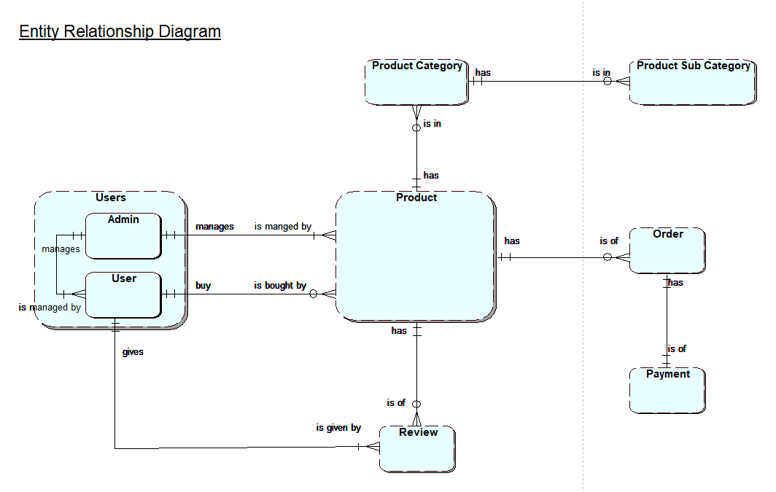

Figure 1: ERD

## 6.2 Use Case Diagram

### 6.2.1 Admin Use Case Diagram

Figure 2: Admin’s Use Case Diagram

### 6.2.2 Customre/User Use Case Diagram

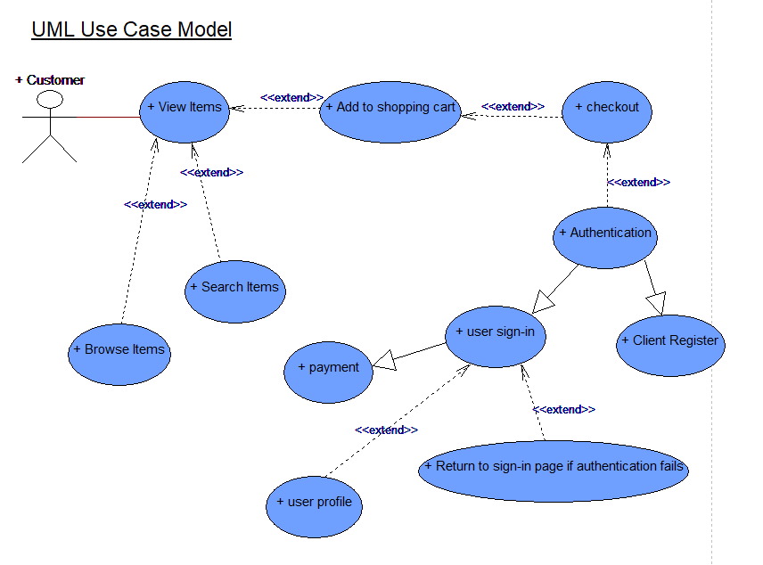

Figure 3: User’s Use Case Diagram

## 6.3 Database Design

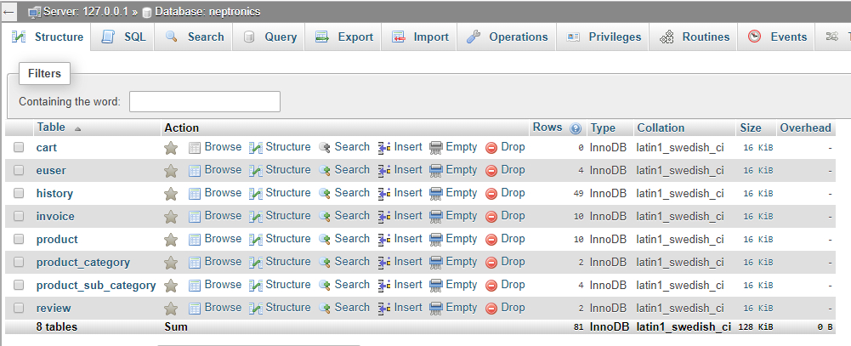

Figure 4: Database design and structure

## 6.3 Data Dictionary

Table Name: EUSER

|  |  |  |  |  |  |  |
| --- | --- | --- | --- | --- | --- | --- |
| ATTRIBUTES | DATA TYPES | INDEXES | CONSTRAINT | DESCRIPTION | MAPPING | DATA QUALITY |
| USER_ID | int | Yes | Primary Key | Unique for identifying a record | Uniquely identifying key | Not Null |
| USER_FIRST_NAME | varchar |  |  | Hold user’s first name |  |  |
| USER_LAST_NAME | varchar |  |  | Hold user’s last name |  |  |
| USER_ADDRESS | varchar |  |  | Hold user’s home address |  |  |
| USER_EMAIL | varchar |  |  | Hold user’s email id |  |  |
| USER_PASSWORD | varchar |  |  | Hold user’s password |  |  |
| ACTIVE | int |  |  | Hold user’s active status |  |  |
| USER_TYPE | varchar |  |  | Hold user’s type i.e. Admin or User |  |  |
| USER_CREATED_AT | varchar |  |  | Hold user created date |  |  |

Table Name: HISTORY

|  |  |  |  |  |  |  |
| --- | --- | --- | --- | --- | --- | --- |
| ATTRIBUTES | DATA TYPES | INDEXES | CONSTRAINT | DESCRIPTION | MAPPING | DATA QUALITY |
| history_id | int | Yes | Primary Key | Unique for identifying a record | Uniquely identifying key | Not Null |
| user_id | int |  |  | Holds the USER_ID as a foreign key | Foreign Key |  |
| change | varchar |  |  | Holds the details of changes made |  |  |
| cdate | varchar |  |  | Holds the date that a detail is changed |  |  |

|  |  |  |  |  |  |  |
| --- | --- | --- | --- | --- | --- | --- |
| ATTRIBUTES | DATA TYPES | INDEXES | CONSTRAINT | DESCRIPTION | MAPPING | DATA QUALITY |
| INVOICE_ID | Int | Yes | Primary Key | Unique for identifying a record | Uniquely identifying key | Not Null |
| INVOICE_NUMBER | Int |  |  | Holds an invoice number of an invoice |  |  |
| USER_ID | Int |  |  | Holds the USER_ID as a foreign key | Foreign Key |  |
| PRODUCT_ID | Int |  |  | Holds the PRODUCT_ID as a foreign key | Foreign Key |  |
| PRICE | Int |  |  | Holds selling price of a product at purchase time |  |  |
| COST_PRICE | Int |  |  | Holds cost price of a product at purchase time |  |  |
| QUANTITY | Int |  |  | Hold quantity of a product ordered |  |  |
| DISCOUNT | Int |  |  | Holds discount percentage given of a product at purchase time |  |  |
| INVOICE_DATE | Varchar |  |  | Hold date of product purchased |  |  |
| PAYMENT_TYPE | Int |  |  | Holds type of payment |  |  |
| PAYMENT_DATE | Varchar |  |  | Holds payment date |  |  |
| PAYMENT_STATUS | Int |  |  | Holds payment status |  |  |
| DELIVERY_STATUS | Int |  |  | Holds delivery status |  |  |
| INVOICE_STATUS | int |  |  | Holds invoice cancelled status |  |  |

Table Name: INVOICE

Table Name: PRODUCT

|  |  |  |  |  |  |  |
| --- | --- | --- | --- | --- | --- | --- |
| ATTRIBUTES | DATA TYPES | INDEXES | CONSTRAINT | DESCRIPTION | MAPPING | DATA QUALITY |
| PRODUCT_ID | Int | Yes | Primary Key | Unique for identifying a record | Uniquely identifying key | Not Null |
| CAT_ID | Int |  |  | Holds the CAT_ID as a foreign key | Foreign Key |  |
| SUB_CAT_ID | Int |  |  | Holds the SUB_CAT_ID as a foreign key | Foreign Key |  |
| PRODUCT_NAME | Varchar |  |  | Holds product’s name |  |  |
| PRODUCT_SHORT_DESCRIPTION | Varchar |  |  | Holds product’s short description |  |  |
| PRODUCT_DESCRIPTION | Varchar |  |  | Holds product’s description |  |  |
| PRODUCT_PRICE | Int |  |  | Holds product’s selling price |  |  |
| PRODUCT_COST_PRICE | Int |  |  | Holds product’s cost price |  |  |
| PRODUCT_OFFER_TITLE | Varchar |  |  | Holds product’s offer title |  |  |
| PRODUCT_DISCOUNT_PERCENT | Int |  |  | Holds product’s discount percent |  |  |
| PRODUCT_QUANTITY | Int |  |  | Holds product’s quantity |  |  |
| PRODUCT_STATUS | Varchar |  |  | Holds product’s active status |  |  |
| PRODUCT_CREATED_AT | Varchar |  |  | Holds product’s created date |  |  |
| PRODUCT_UDATED_AT | Varchar |  |  | Holds product’s latest updated date |  |  |
| PRODUCT_IMAGE_PATH | Varchar |  |  | Holds product’s image in blob |  |  |

Table Name: PRODUCT_CATEGORY

|  |  |  |  |  |  |  |
| --- | --- | --- | --- | --- | --- | --- |
| ATTRIBUTES | DATA TYPES | INDEXES | CONSTRAINT | DESCRIPTION | MAPPING | DATA QUALITY |
| cat_id | int | Yes | Primary Key | Unique for identifying a record | Uniquely identifying key | Not Null |
| NAME | Varchar |  |  | Holds product category’s name |  |  |

Table Name: PRODUCT_SUB_CATEGORY

|  |  |  |  |  |  |  |
| --- | --- | --- | --- | --- | --- | --- |
| ATTRIBUTES | DATA TYPES | INDEXES | CONSTRAINT | DESCRIPTION | MAPPING | DATA QUALITY |
| sub_cat_id | int | Yes | Primary Key | Unique for identifying a record | Uniquely identifying key | Not Null |
| cat_id | int |  |  | Holds product category id | Foreign Key |  |
| NAME | Varchar |  |  | Holds product sub-category’s name |  |  |

Table Name: REVIEW

|  |  |  |  |  |  |  |
| --- | --- | --- | --- | --- | --- | --- |
| ATTRIBUTES | DATA TYPES | INDEXES | CONSTRAINT | DESCRIPTION | MAPPING | DATA QUALITY |
| REVIEW_ID | int | Yes | Primary Key | Unique for identifying a record | Uniquely identifying key | Not Null |
| PRODUCT_ID | int |  |  | Holds the PRODUCT_ID as a foreign key |  |  |
| REVIEW_DESCRIPTION | Varchar |  |  | Holds review’s description |  |  |
| REVIEW_CREATED | Varchar |  |  | Holds review created date |  |  |
| USER_ID | int |  |  | Holds user_id of a user who has given review |  |  |
| REVIEW_RATING | int |  |  | Holds review’s rating number |  |  |

## 6.4 Front End Website

Figure 5: Home page of our website

Above is the index or home page of our website. Products are arranged in high to low order on the basis of discount amount. Bottom row is for newest product on our website.

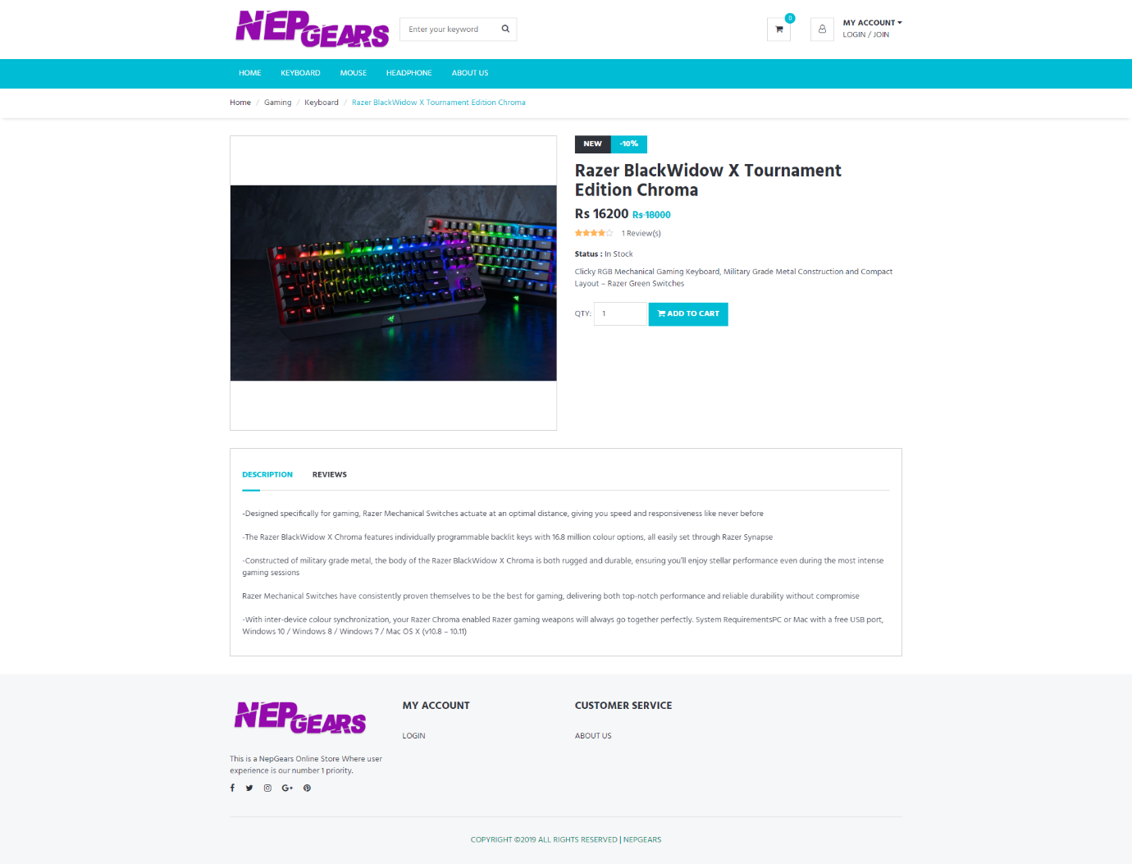Figure 6: Products Details Page

This is a page where product’s details are shown. You can also view reviews and rating of that product. You can add products to cart and checkout from this page.

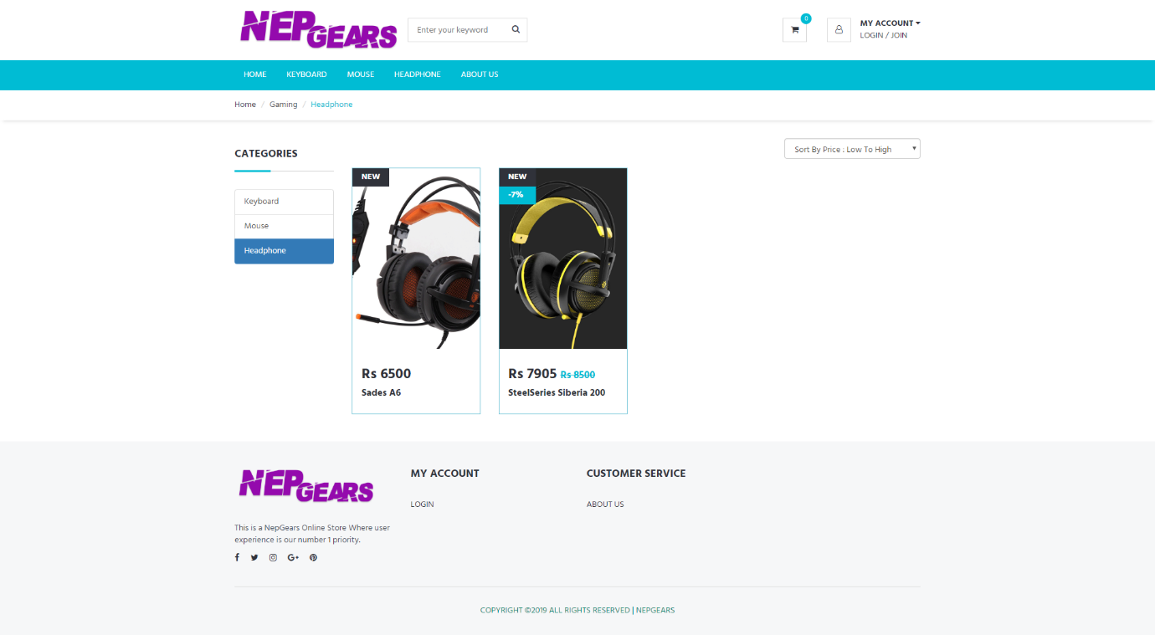Figure 7: Browse product with categories page

Since our website is small for now, and only has limited product and categories. You don’t even need to search a product you can just browse and check all the products from this page. You can also sort products according to price or discounts.

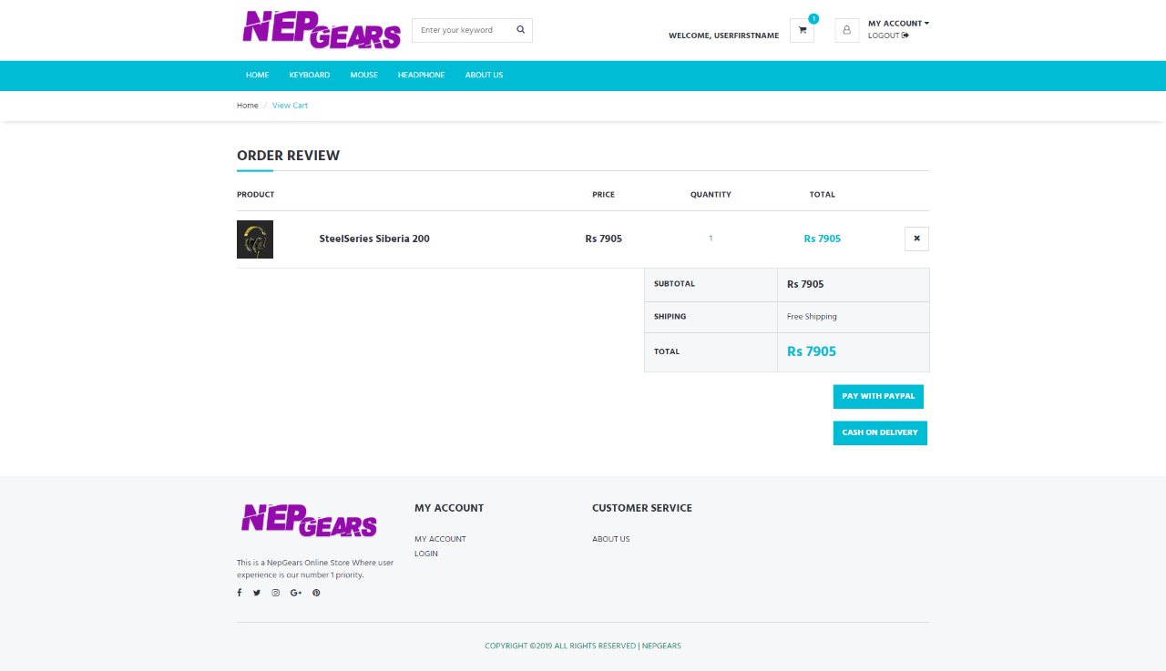

Figure 8: View cart and checkout page

You can view your products in cart and you can checkout from this page. You can add products to cart even if you are not signed in but you need to sign in to checkout. There are two payment options. First is pay with PayPal, you can pay for this product online using PayPal as a payment gateway. Secondly, you can use cash on delivery where you need to pay the delivery guy once it reaches you.

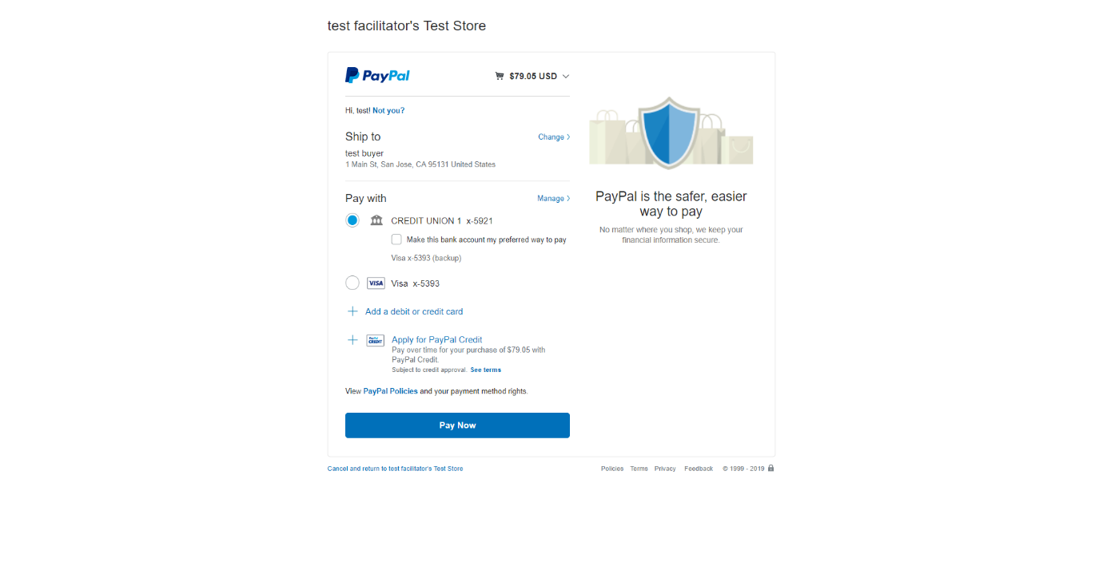Figure 9: PayPal confirmation page

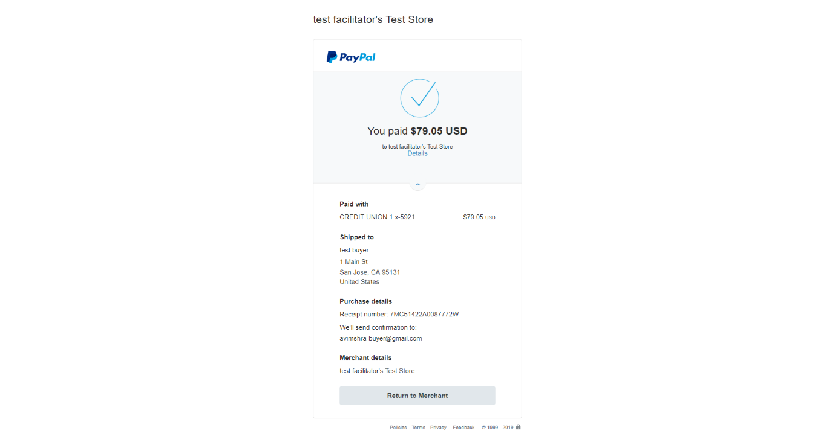 PayPal confirmation page looks like this where you are to confirm to pay for the product.

Figure 10: PayPal Payment Success page

Once payment is successfully done with PayPal this page shows up. This is also a payment confirmation. You can then return to merchant to view invoice.

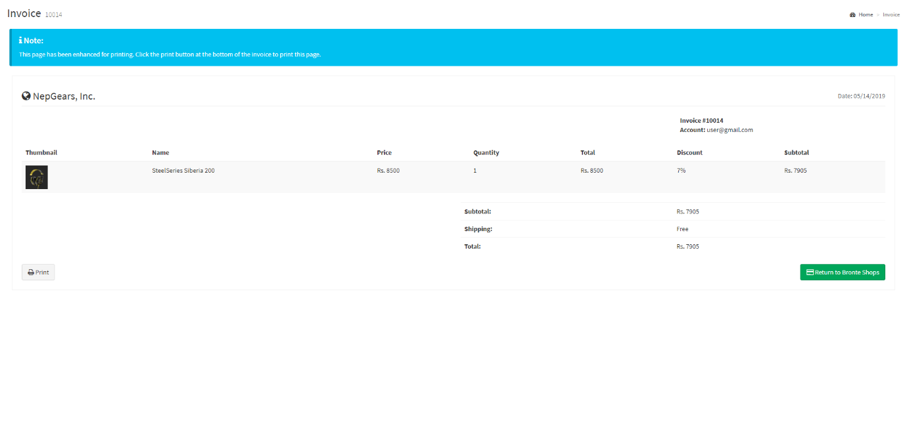Figure 11: View Invoice Page

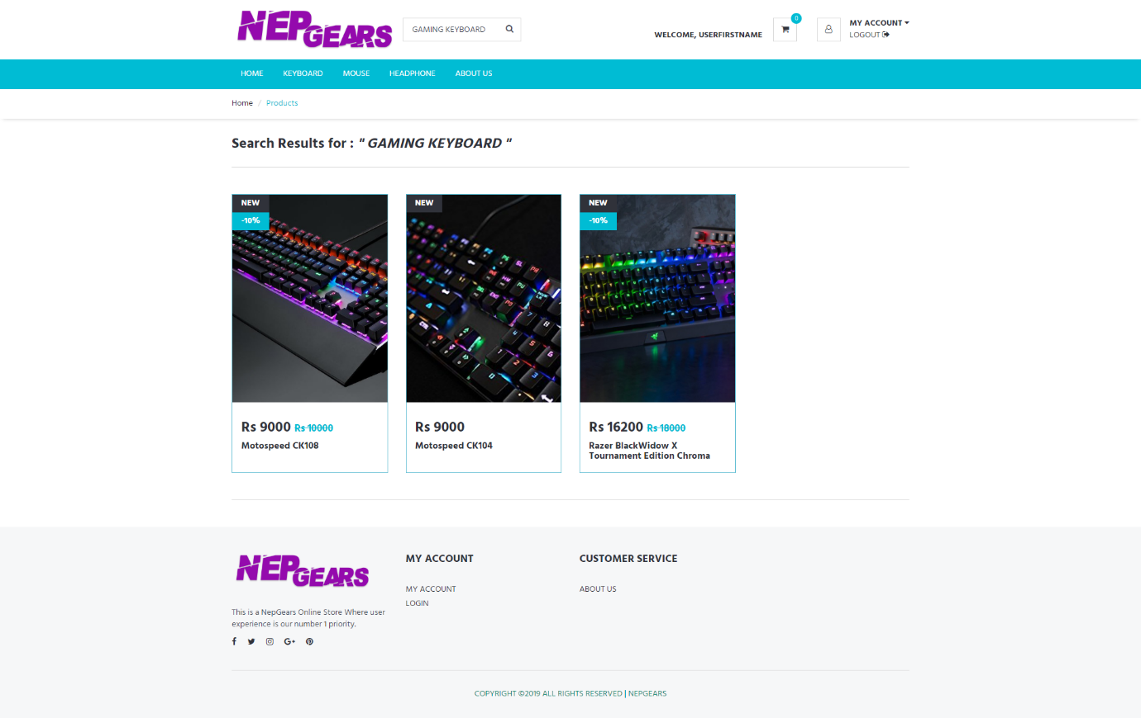 You can view your invoice where product details, discount and total are shown.

Figure 12: Products Search Page

There is a search bar at top of our website where you can search products in our website. This is how products will be displayed.

## 6.5 Back End Website

Figure 13: Sign In Page for both Admin and User

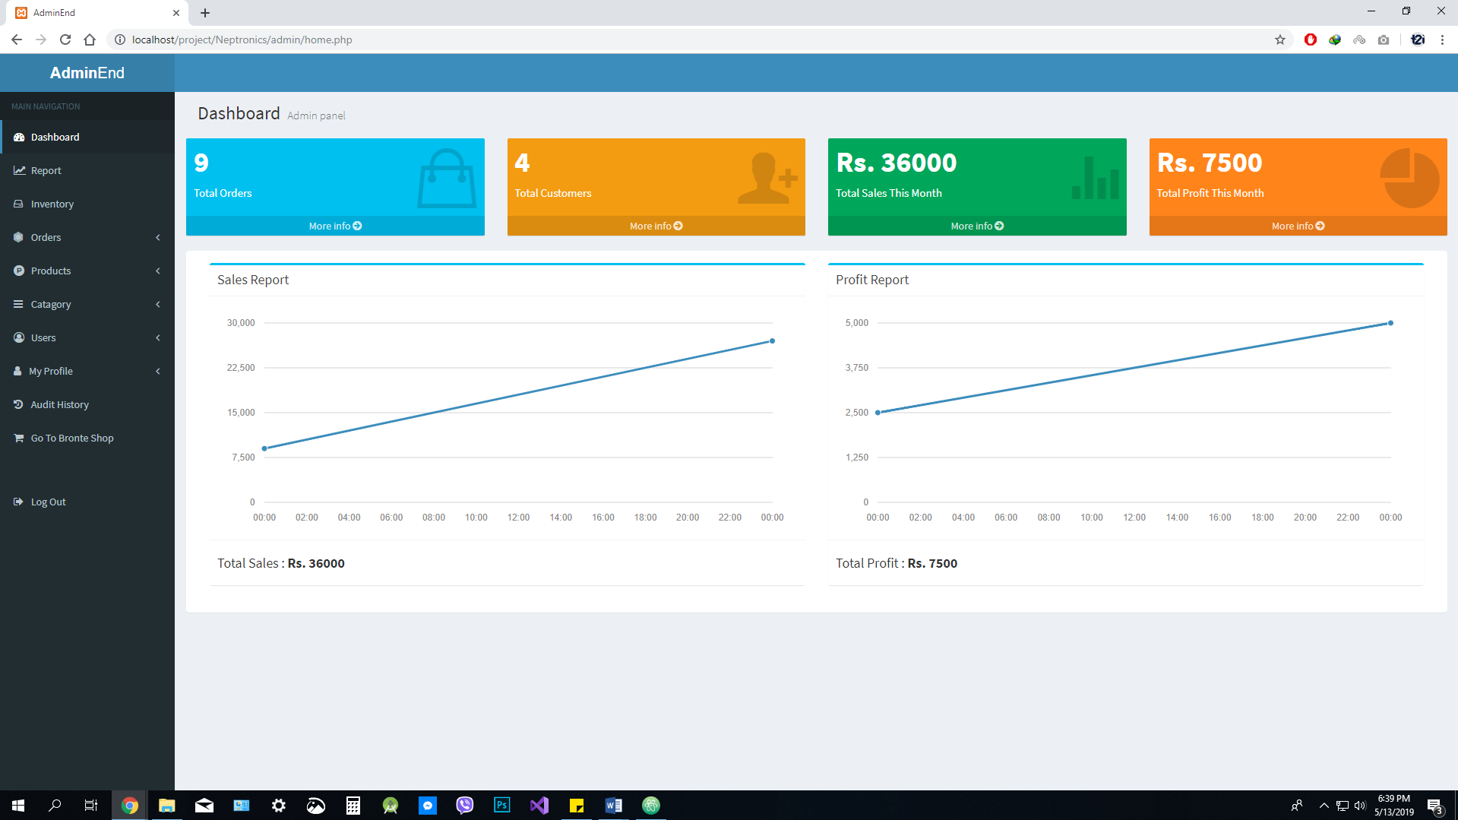This is the sign in page of both admin and user. Admin sign in will take to admin dashboard whereas user sign in will take you to home page.

Figure 14: Admin Dashboard

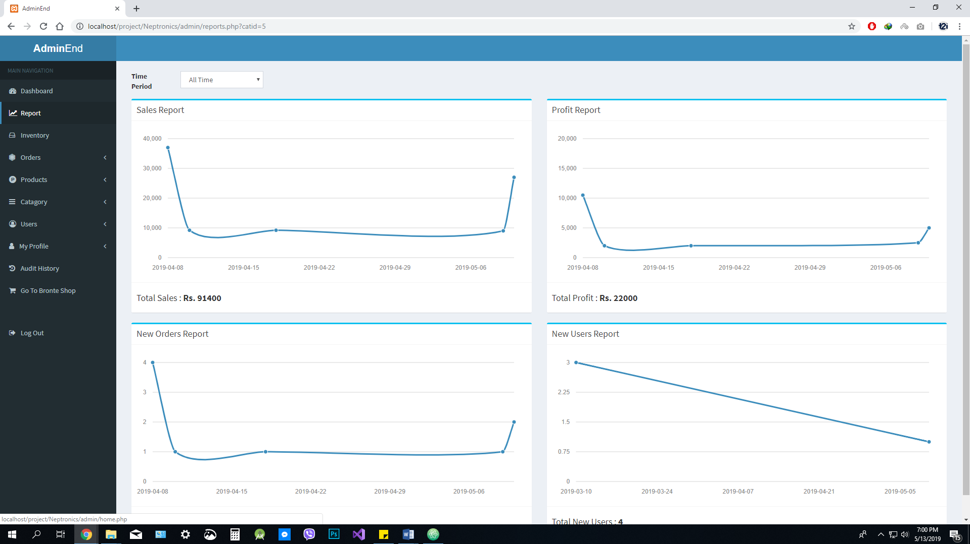The above picture is of admin’s dashboard, you can see different kinds of information and navigate to other pages from here.

Figure 15: Reports Page

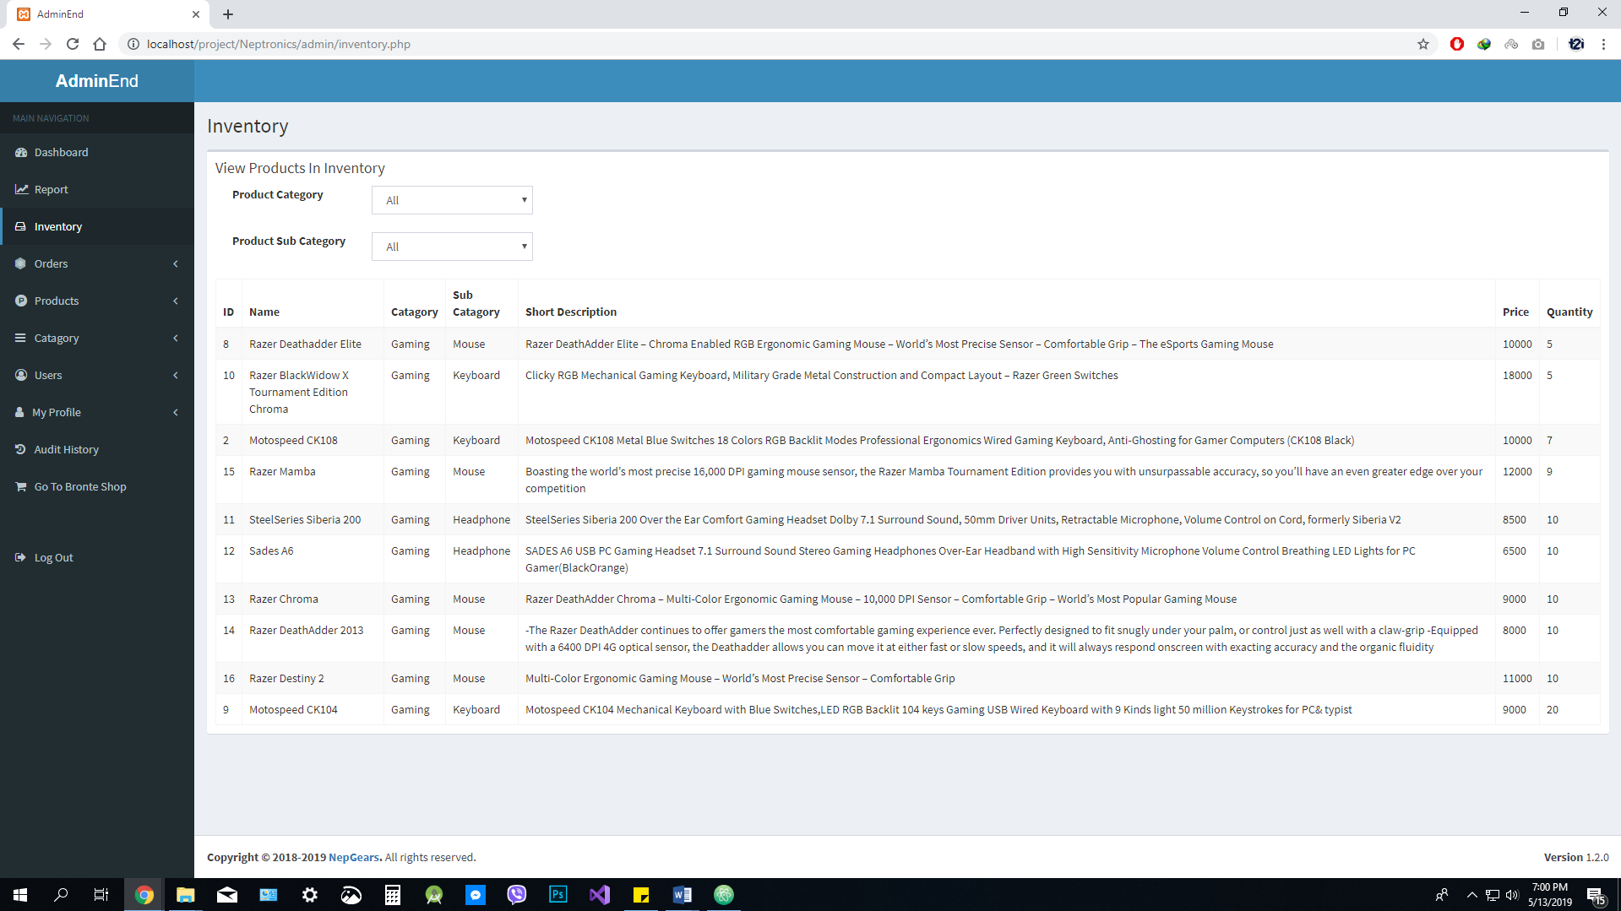This is the most important page to track sales and progress of a business. You can see sales, profit, orders and new users add report all at once of various time periods. You can change the time period of these report and observe them.

Figure 16: View Inventory Page

This is a page where you can see products in your inventory with least quantity at first. So you can plan accordingly to order products.

Figure 17: View and Manage Orders Page 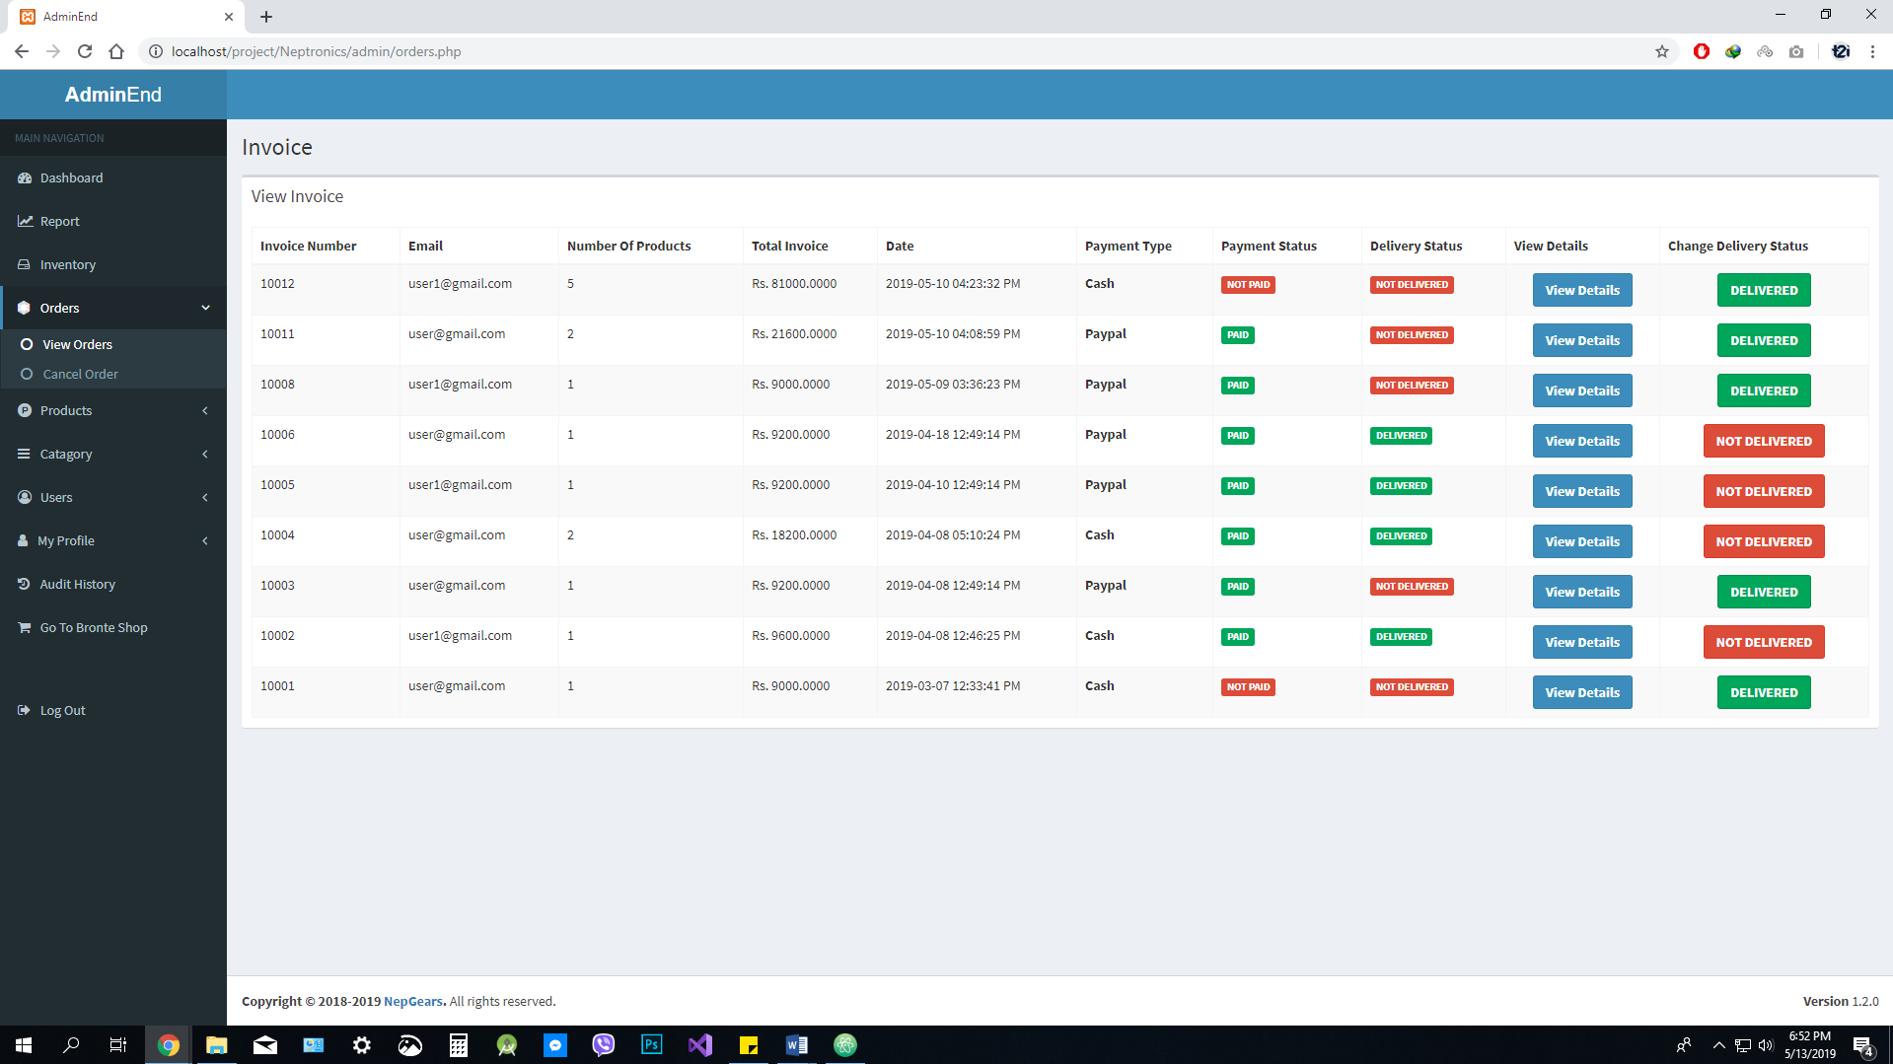

In this page you can see details of an invoice. You can set products to delivered and not delivered according to the delivery status.

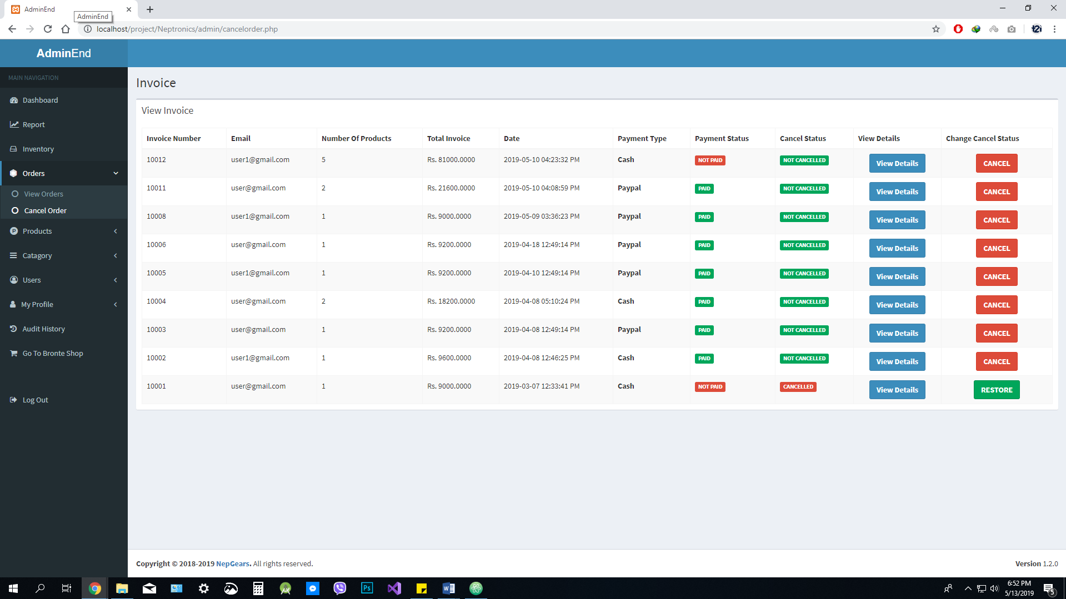

Figure 18: View and Cancel Orders Page

In this page you can see details of an invoice. You can set products to cancelled and not cancelled according to the cancellation status.

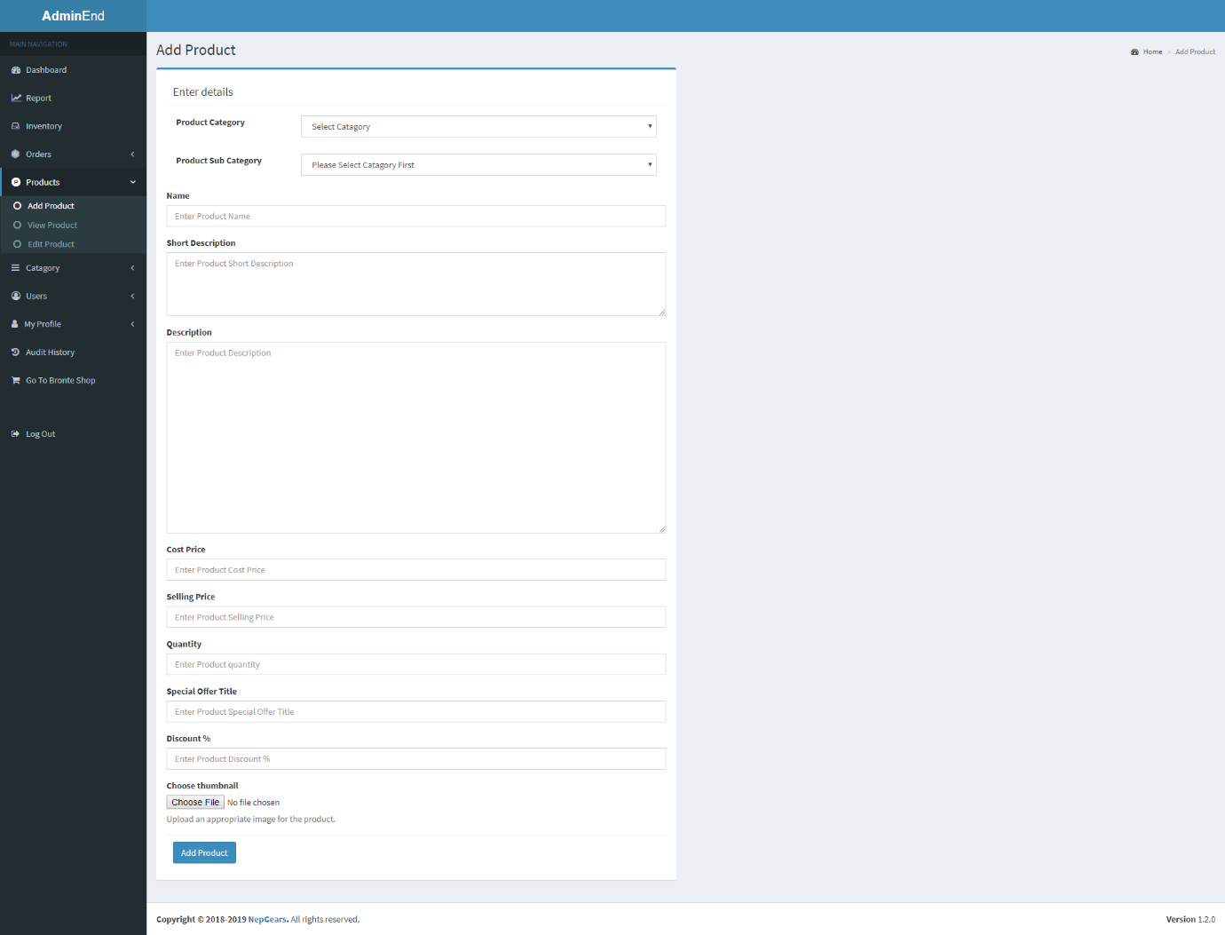Figure 19: Add Products Page

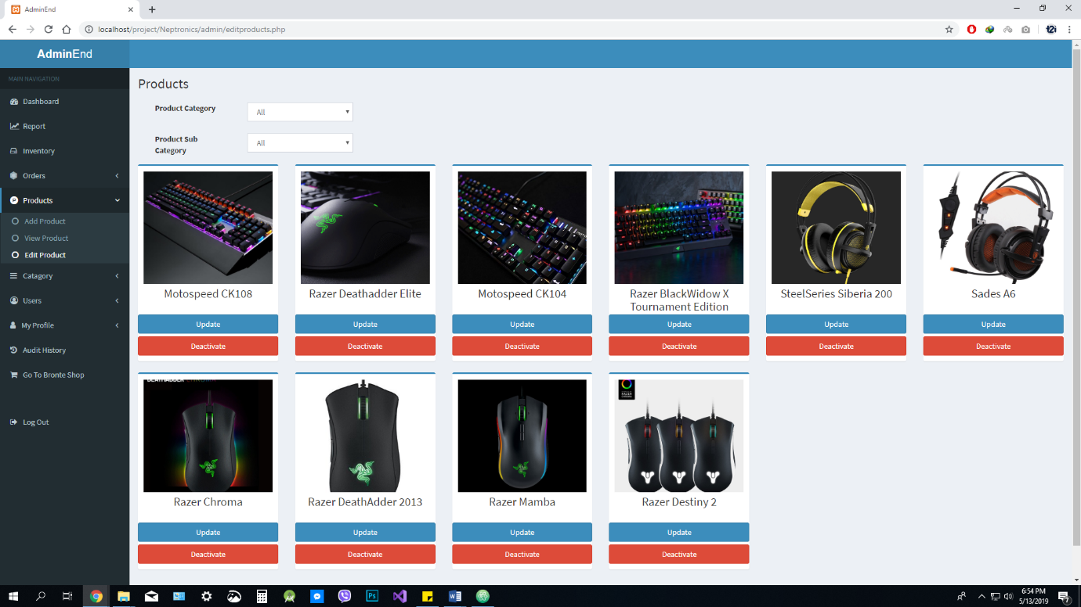This is a page to add a products to the database.

Figure 20: View, edit and manage Products Page

In this page you can go to edit details page by clicking update button. You can also active or deactivate a product by clicking respective buttons.

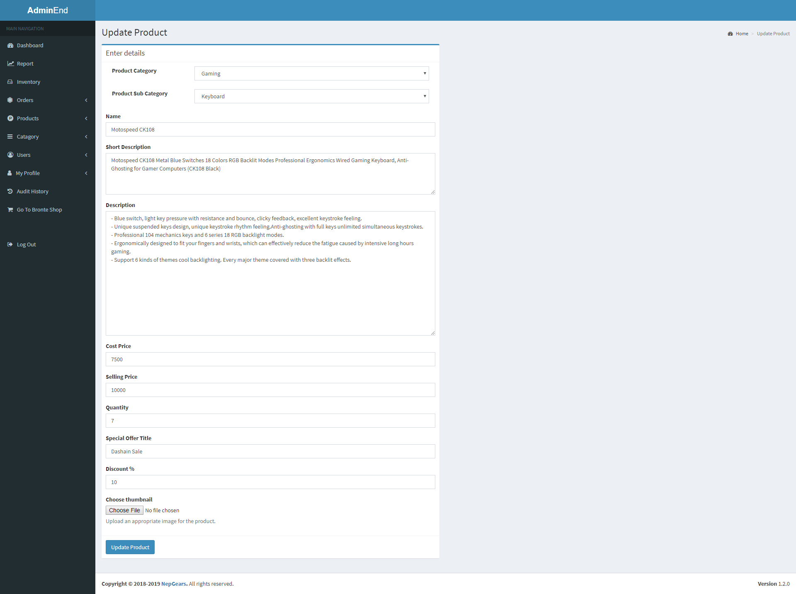Figure 21: Edit Products Page

You can edit product’s details and save them in this page.

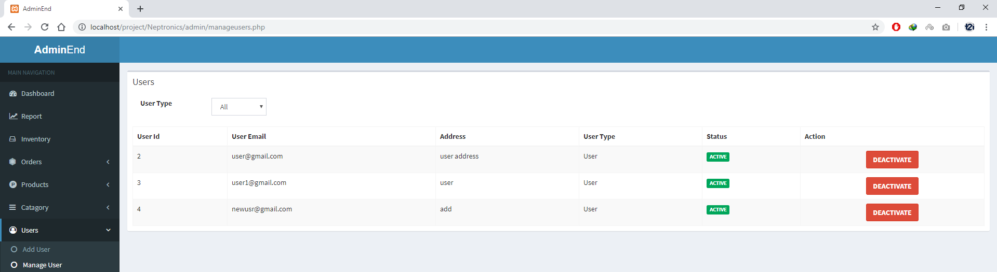Note: Add, Update and Delete for Product’s categories and product’s sub categories are same as above mentioned product’s process. So they are not shown here.

Figure 22: Manage Users Page

In this page you can manage users by activating or deactivating them.

Figure 22: Audit History Page 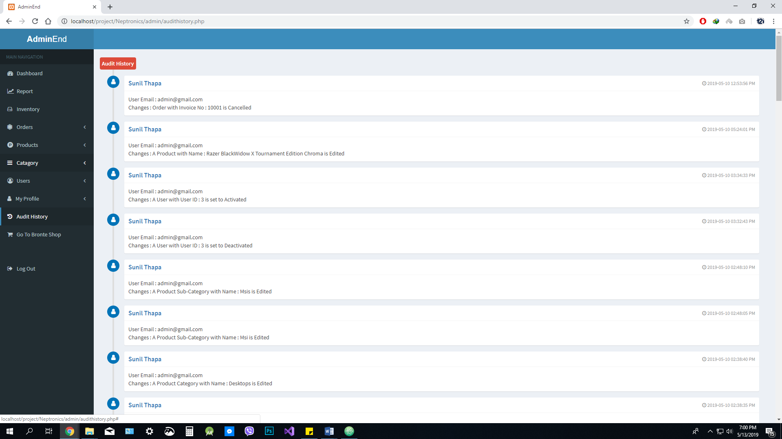

This is the place where you can see everything that an admin has changed. This will keep all those thing in database. This will help you see everything other admins have done.

# 7.0 PRODUCT TESTING

Testing was completed after completion of every module. For the most part, testing is done at the end of the SDLC (Software Development Life Cycle) however since the approach picked was agile, testing was directed toward the finish of consummation of every module. Testing is completed to check the created product. Manual testing was done as opposed to utilizing a computerized testing apparatus. Test cases were set up for checking distinctive usefulness of a module. The reason for testing programming is to see that every one of the parts is incorporated together and the segment being tried satisfies its motivation. Testing a software can prompt two outcomes to start with, the code works appropriately and requirement is fulfilled.

There are two types of testing: Black-box testing and White-box texting. Black-box testing is carried out to check the functionality of the software. The tester is given a set of input and is given a desired output for those inputs. If the desired output is received then the test is successful. White-box testing is carried out to make the software more efficient usually the software contains no bugs it is carried out to make the software faster and better functioning.

A product can be tested at different levels during the lifecycle of the product. After the completion of a module the module is tested and validated before moving unto a new module. Testing can be carried out in different stages of the SDLC. Below is the list of testing approach that was applied during the product development.

## 7.1 Unit Testing

In agile model unit testing is the main form of testing. It is conducted after the completion of each unit to check whether it functions properly or not. Once the unit is tested bug free then the developer moves into the next unit of the project.

White-box testing is carried in unit testing by the programmer himself because the tester knows the codes better.

## 7.2 Integration Testing

Integration testing is conducted to see that different units combined together works as expected. Usually when a part of a project passes unit testing it is not necessary that it works properly when integrated with other such parts of the project. This type of testing falls under both: black-box and white-box approach.

## 7.3 System Testing

After the completion of the product it is tested as single software. It is tested against the requirement specification to check that all the functionality works as desired. Black-box testing is applied in system testing. After the completion of the product and putting it through unit and integration technique the product is hosted and the testing is applied again. This shows that the product functions well in a working environment.

All of the above testing methods were applied to the product to check that all product requirements are fulfilled and it functions properly. It is shown below in test cases.

## 7.4 Test Cases

These are the test cases performed to check full functionality of our website.

**Admin’s Test Case**

|  |  |  |  |
| --- | --- | --- | --- |
| Test Case | Steps | Expected Result | Pass/Fail |
| Login | Enter valid credentials | Redirects to the Admin Dashboard | Pass |
| Dashboard | Dashboard is clicked on Navigation bar. | Dashboard should be shown. | Pass |
| Report | Report is clicked on Navigation bar. | Graphical reports should be shown. | Pass |
| Inventory | Inventory is clicked on Navigation bar. | Inventory should be shown with stocks. | Pass |
| View Order | View Order is clicked on Navigation bar. | Orders should be shown. | Pass |
| View Order Details | View Details is clicked on Table list. | It should open a new page with invoice details. | Pass |
| Change Delivery Status | Delivered button is clicked on Table list. | It should change its name to not delivered and color to Red. It should also change delivery status to “Delivered”. | Pass |
| Change Delivery Status | Not Delivered button is clicked on Table list. | It should change its name to delivered and color to Green. It should also change delivery status to “Not Delivered”. | Pass |
| Cancel Order | Cancel button is clicked on Table list. | It should change its name to “Restore” and color to Green. It should also change cancel status to “Cancelled”. It should also increase product quantity that is canceled. | Pass |
| Restore Order | Restore button is clicked on Table list. | It should change its name to “Cancel” and color to Red. It should also change cancel status to “Not Cancelled”. | Pass |
| Add Product | Entered with valid data | It should save a new product to database and show saved message. | Pass |
| View Product | View Product is clicked on Navigation bar. | Products should be listed and shown in table. | Pass |
| Edit Product | Edit Product is clicked on Navigation bar. | Products should be shown with images. | Pass |
| Update Product | Update Product is clicked on product’s detail. | A new page should open with all the details loaded. | Pass |
| Save Product Changes | Save changes button is clicked on. | All changes are saved in database. A message is shown after success and view product page is opened. | Pass |
| Add Product Category | Entered with valid data. | It should save a new Product Category to database and show saved message. | Pass |
| Edit Product Category | Entered with valid data. | It should save a Product Category changes to database and show changes saved message. | Pass |
| Delete Product Category | Delete button is clicked. | It should Delete a new Product Category from database and show is deleted message. | Pass |
| Add Product Sub Category | Entered with valid data | It should save a new Product Sub Category to database and show saved message. | Pass |
| Edit Product Sub Category | Entered with valid data. | It should save a Product Sub Category changes to database and show changes saved message. | Pass |
| Delete Product Sub Category | Delete button is clicked. | It should Delete a new Product Sub Category from database and show is deleted message. | Pass |
| Add Admin | Entered with valid data | A new user or admin is added to database and success message is shown. | Pass |
| Manage User | Manage User is clicked on Navigation bar. | A page is shown with list of names to activate or deactivate. | Pass |
| Activate User | Activate button is clicked. | A user should be activated and message should be shown saying a user has been successfully activated. | Pass |
| Deactivate User | Deactivate button is clicked. | A user should be deactivated and message should be shown saying a user has been successfully deactivated. | Pass |
| View Profile | View Profile is clicked on Navigation bar. | A page with user details should be shown. | Pass |
| Edit Profile | Edit Profile is clicked on Navigation bar. | A page with user details should be shown which is editable. | Pass |
| Save Profile Changes | Entered with valid data. | It should save changes to database and show changes saved message. | Pass |
| Audit History | Audit History is clicked on Navigation bar. | It should show all audit histories in list. | Pass |
| Log Out | Log Out is clicked on Navigation bar. | It should log out a user and open Nepgears home page. | Pass |

**User’s Test Case**

|  |  |  |  |
| --- | --- | --- | --- |
| Test Case | Steps | Expected Result | Pass/Fail |
| Registration | Simple registration with validated data | Redirects to the Login Page | Pass |
| Login | Enter valid credentials | Redirects to the Nepgears Home Page | Pass |
| View Profile | View Profile is clicked on Navigation bar. | A page with user details should be shown. | Pass |
| Edit Profile | Edit Profile is clicked on Navigation bar. | A page with user details should be shown which is editable. | Pass |
| Save Profile Changes | Entered with valid data. | It should save changes to database and show changes saved message. | Pass |
| View Order | View Order is clicked on Navigation bar. | Orders should be shown. | Pass |
| View Order Details | View Details is clicked on Table list. | It should open a new page with invoice details. | Pass |
| Log Out | Log Out is clicked on Navigation bar. | It should log out a user and open Nepgears home page. | Pass |

**Front-End’s Test Case**

|  |  |  |  |
| --- | --- | --- | --- |
| Test Case | Steps | Expected Result | Pass/Fail |
| Add To Cart | Add to cart button is pressed. | Add products to a cart and display added message. | Pass |
| Pay with PayPal | Pay with PayPal button is pressed. | It should open a PayPal payments page and after successful payment, it should return back to Nepgears website with an invoice created. It should also decrease product quantity that is ordered. |  |
| Cash On Delivery | Cash On Delivery button is pressed. | It should create an invoice and show invoice details. It should also decrease product quantity that is ordered. |  |
| Submit Review | A review star is selected and a review text is given. | A review should be saved and success message should be shown. |  |

# 8.0 PRODUCT EVALUATION

This portion of the report deals with a final overall comparison and tally of all the features and functionalities that have been wrapped in the final product. Different than the testing, it only ensures that the product has remained in the same form and design from what had been initially planned. The main objective here is to assess the process the implementation, the effects or changes that have come during the product development and taking notes of problems and halts that were faced along the process. The initial project plan carries a lot of significance here as it contains the base guidelines for the overall development of the project. Thus, for the product evaluation of this project, the initial project plan was taken as a reference.

After the research on the best features that were popular on international ecommerce websites, it was decided that PayPal payment method and Reviews for product added. To run an ecommerce business you will definitely need an online payment method and for our case PayPal was integrated which will make user’s payment process much more efficient. Our products will also have reviews on them given by different users on different times. The system takes in the average amount of review score and divides it among the number of users who have given product’s review. This calculated data is properly proportional with the actual rating bar and relevant stars of review is shown. This will ensure product quality.

The login system was another major part of the application which allowed either admin or normal users to log into the system. Like in any other log-in systems, the application consisted form input field where users can input their credentials. Validation of passwords and encryption of those information were the primary feature to be implemented on this part of the application. MD5 encryption has been adopted for the safest possible encryption. The system obviously does not allow unauthorized user to enter inside the application.

On the admin end, there is a dashboard designed to give overview of sales and profit report of the store. A sales and profit report can be generated of different time periods in admin’s section. This will provide great feature for business owner as they can see each day’s report on a graphical form. Admin can view, add, and edit products in stock. He can also activate or deactivate a user as per requirement.

Hence, it can be concluded for the evaluation that all of the features that were planned in the initial project plan are completed.

# 9.0 PROJECT EVALUATION

Evaluation for each of the objectives mentioned in the initial project plan has been carried out below:

The first objective mentioned in the project plan was to and develop a website to store and sell products online. It can be agreed that this objective has been well met as our website or a project as a whole is completed. Our website is fully functional and it is ready to go live online.

The second objective mentioned in the project plan was to make buying product online fast and easy. We cannot argue that online system is automatically easy and fast but to make this feature more dominant, we have implemented PayPal payment method. It make payment process hassle free, it makes it so easy that it can be done with one click.

The third objective mentioned in the project plan was to track inventory and sales. There is a admin panel that lets you view and track products in an inventory. There is a reports tab as well which shows the graphical representation of sales and even profit made by the store online.

Direct online researches were done with gamers initially to make important decisions at the start of the planning for development of the product. A lot of data related to the opening store and selling gaming products was gathered. Those initial set of data aided in understanding of customers requirement and to decide what kind of products can be sold in the local Nepalese market. This research was designed to extract as much valuable data that could be gathered in the given limited time frame. As no information related to the Nepalese gaming industry was found online, it had to be made sure that all the necessary information that would be required to make further important decisions for the progress of the product, were achieved from this research. At the end of the research, all data of the data was collected. It was found that the data achieved was actually very genuine and answered all the key questions to make further decisions in designing the website.

# 10.0 CONCLUSION

It is very clear that ecommerce have revolutionized the ways in which people can benefit alot. The efforts that are put into developing such website are tremendously intricate. However, with proper understanding of the basic programming logics and technologies used, it becomes more manageable to produce websites which are not as highly sophisticated as the ones used in international market. Nevertheless, it is now known from research that even a simple website like the one built for this project can provide huge benefits for gamers in gaming communities.

All the researches performed were found to be very useful when it came to knowing about a lot of fine details that were to be considered while developing this project. It was learnt that managing an overall project dedicated towards a website development requires extensive advance planning.

# 11.0 BIBLIOGRAPHY

*2005 Essential Facts about the Computer and Video Games Industry* (2005), Entertainment Software Association, <http://www.theesa.com/facts/index.php>

BBC NEWS (2004/12/30), “Blockbuster games battle for 2004 crown,” <http://news.bbc.co.uk/go/pr/fr/-/1/hi/technology/4091959.stm>

Braun , C. *&* Giroux, J. (1989), “Arcade video games: Proxemic, cognitive and content analyses,” *Journal of Leisure Research*, *Business Week* (2004)

Gartenberg, M. (2004), “Industry Snapshot: Stats and Metrics” in IGDA Developer Business Summit 2004 Game Developers Conference, eds. Douglas M. McCracken Jr., and Sharon A. Richardson, IGDA: USA.

Levitt, T. (1960), Marketing Myopia, *Harvard Business Review*, July/August.

Lowenstein, D. (2004), E3 2004 State of the Industry Address, <http://www.theesa.com/archives/2004/05/e3_2004_state_o_1.php>

How to write a proper Background of Study [Online] Available from:

<https://www.editage.com/insights/how-to-write-the-background-to-the-study-in-a-research-paper>

How to write Literature Review [Online] Available from:

<https://library.concordia.ca/help/writing/literature-review.php>

QSEE Technologies from: https://www.leedsbeckett.ac.uk/qsee/

Nepal Country Commercial Guide (2019) [Online] Available from:

<https://www.export.gov/article?id=Nepal-ecommerce>

E Commerce in Nepal Presenting New Opportunities for Fashion Industry [Online] Available from: <https://www.imnepal.com/ecommerce-business-nepal-website>

4 Studies That Show How E-Commerce Changed (2017) [Online] Available from: <https://www.convinceandconvert.com/digital-marketing/how-ecommerce-changed-in-2017/>

Ecommerce Market Research (Peters, 2019) [Online] Available from: <https://sumo.com/stories/ecommerce-market-research>

Global E-commerce Payment Market Analysis and Forecasts (Globenewswire, 2018) [Online] Available from: <https://www.globenewswire.com/news-release/2018/09/10/1568358/0/en/Global-E-commerce-Payment-Market-Analysis-and-Forecasts-2018-2025-Lowering-Entry-Barriers-In-the-Payment-Service-Market-Together-with-Technological-Advancement-will-Create-Favourab.html>

The global e-commerce growth (Cision, 2018) [Online] Available from: <https://www.prnewswire.com/news-releases/the-global-e-commerce-payment-market-accounted-for-us-24-26-bn-in-2017-and-is-expected-to-grow-at-a-cagr-of-13-1-over-the-forecast-period-20182025--to-account-for-us-64-69-bn-in-2025--300709654.html>

Service Industry & Others segment is leading the global e-commerce payment market by 2025 (Joshi, 2019) [Online] Available from: <https://www.reportsweb.com/press-release/e-commerce-payment-market>

Johnson, S. (2005). Everything Bad Is Good For You: Today’s Popular Culture Is Actually Making Us Smarter. New York, NY: Penguin Group.

DeMaria, R. (2010). Reset: Changing the way we look at video games. San Francisco, CA: Berrett-Koehler Publishers, Inc., 2007.

McGonigal, J. (2011). Reality Is Broken: Why Games Make Us Better and How They Can Change the World. New York: Penguin.

Strategies, Trends & Opportunities for the $96 Billion Market (Cision, 2019) [Online] Available from: <https://www.prnewswire.com/news-releases/global-video-games-industry-report-2019-strategies-trends--opportunities-for-the-96-billion-market-300825458.html>

Video game revenue tops $43 billion in 2018, an 18% jump from 2017 (Shieber, 2019) [Online] Available from: <https://techcrunch.com/2019/01/22/video-game-revenue-tops-43-billion-in-2018-an-18-jump-from-2017/>

Digital Games Saw 12% Growth to $113.4 Billion in 2018 (Vincent, 2019) [Online] Available from: <https://variety.com/2019/gaming/news/superdata-2018-year-in-review-results-1203109940/>

U.S. Video Game Sales Reach Record-Breaking $43.4 Billion in 2018 (Washington Press Release, 2019) [Online] Available from: <http://www.theesa.com/article/u-s-video-game-sales-reach-record-breaking-43-4-billion-2018/>

Insights Into the $137.9 Billion Global Games Market (Wijman, 2018) [Online] Available from: <https://newzoo.com/insights/articles/newzoos-2018-report-insights-into-the-137-9-billion-global-games-market/>

# 12.0 APPENDICES

APPENDIX A



Figure 1: ERD

Figure 2: Admin’s Use Case Diagram

Figure 2: User’s Use Case Diagram 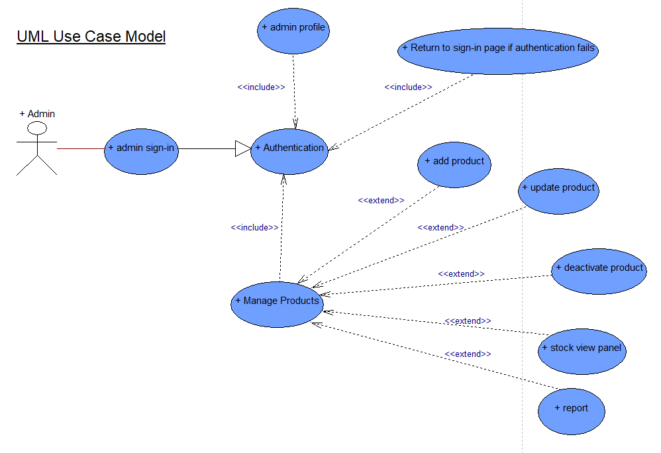

APPENDIX B

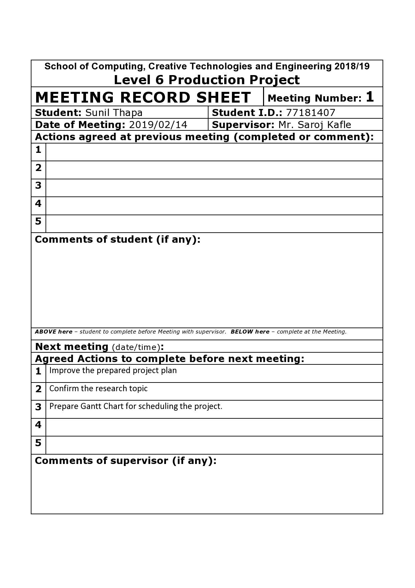**Meeting Record Sheets: (Screenshots)**

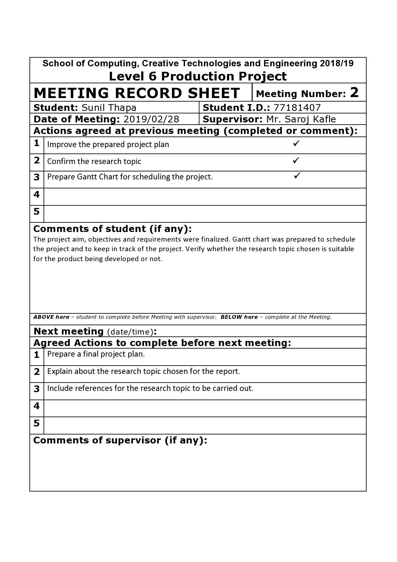

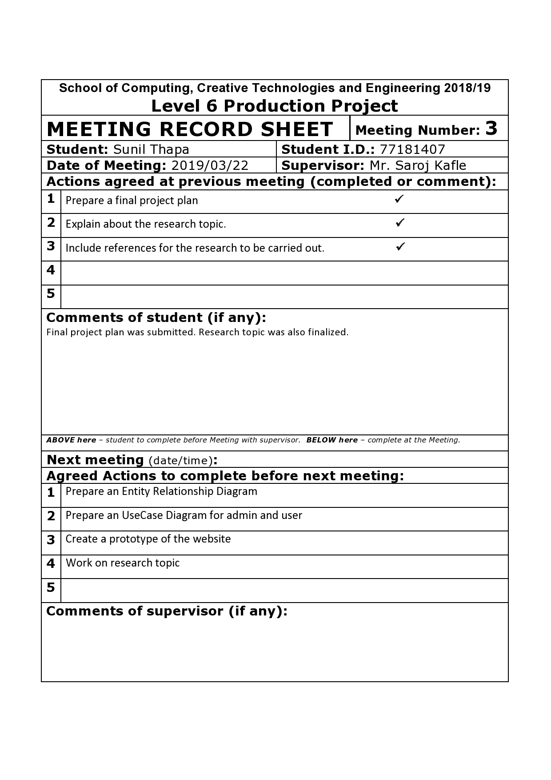

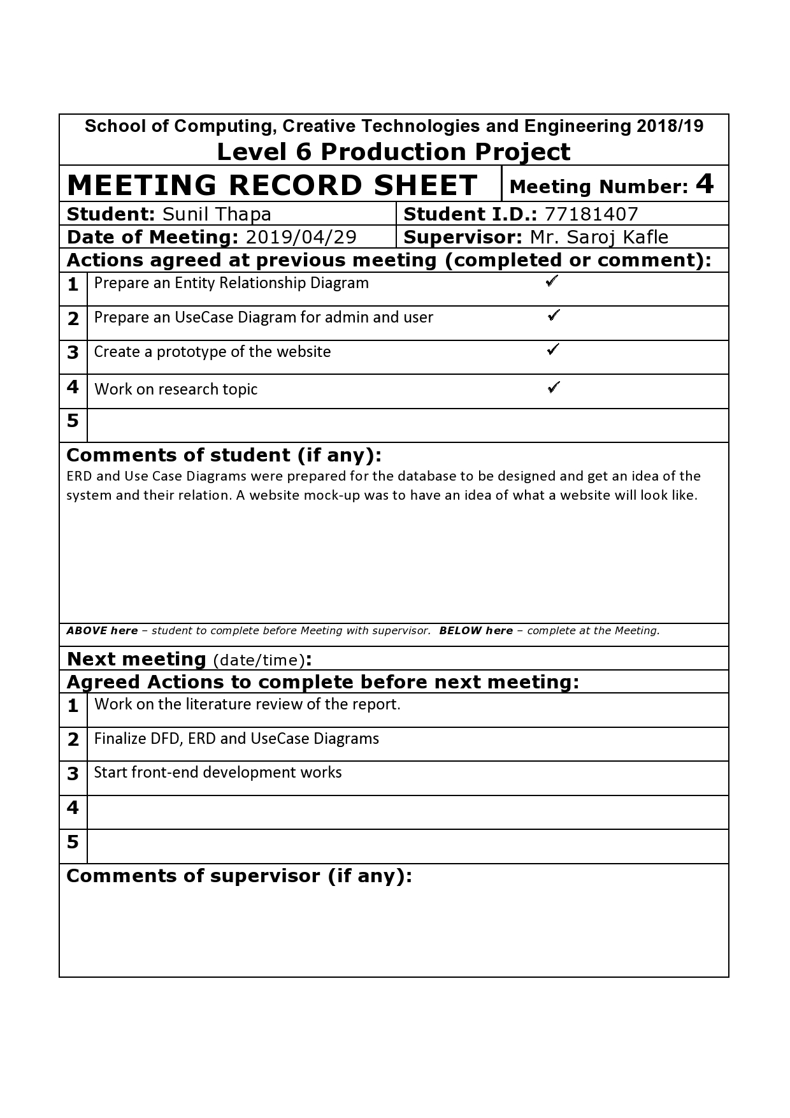

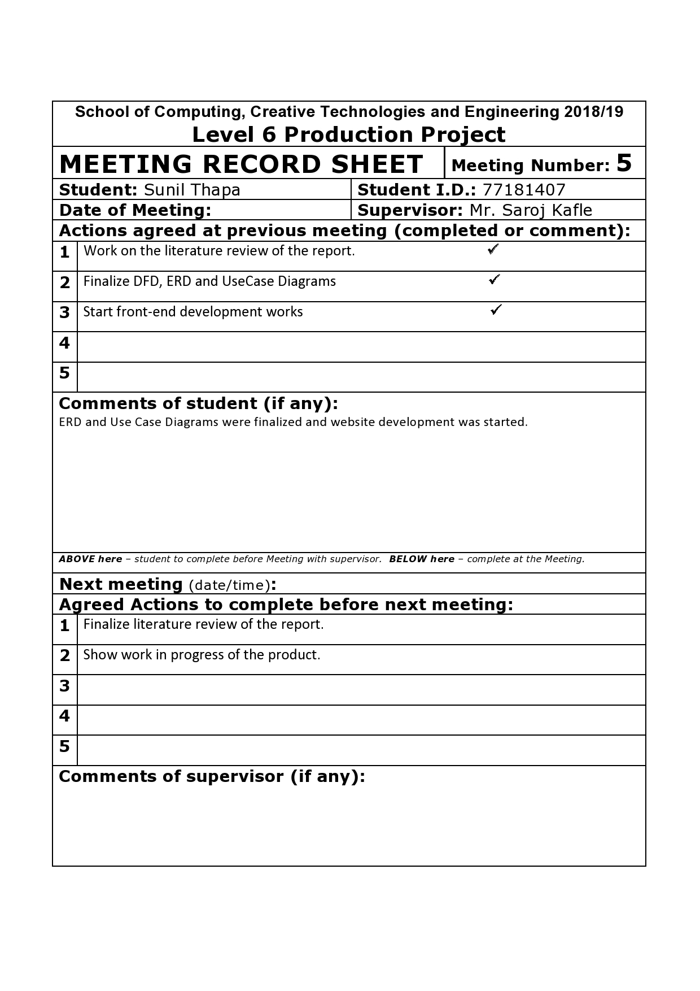

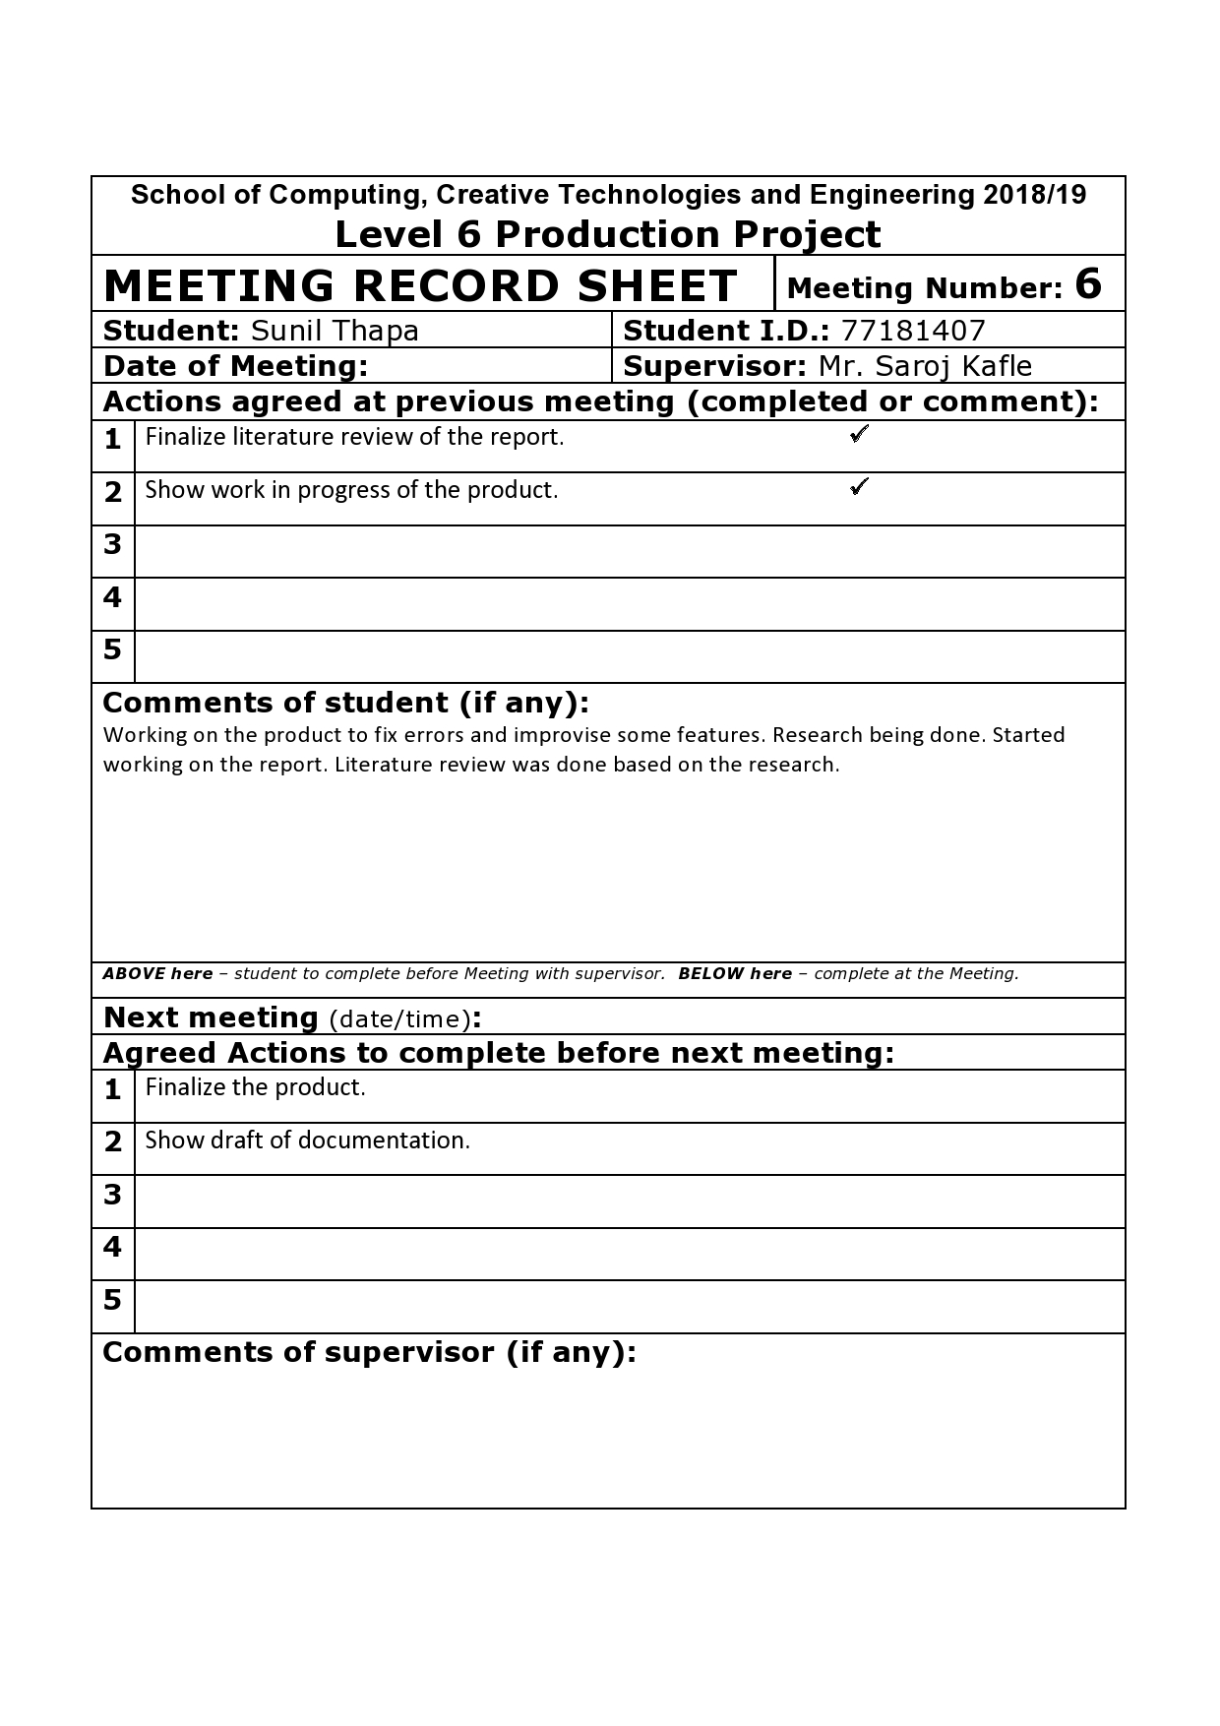

## APPENDIX C

**Initial Project Plan: (Screenshots)**

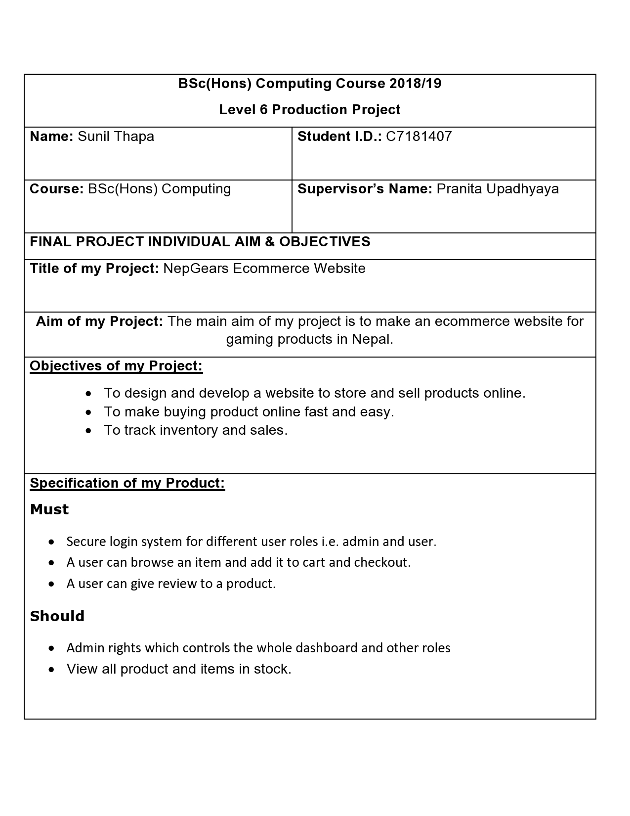

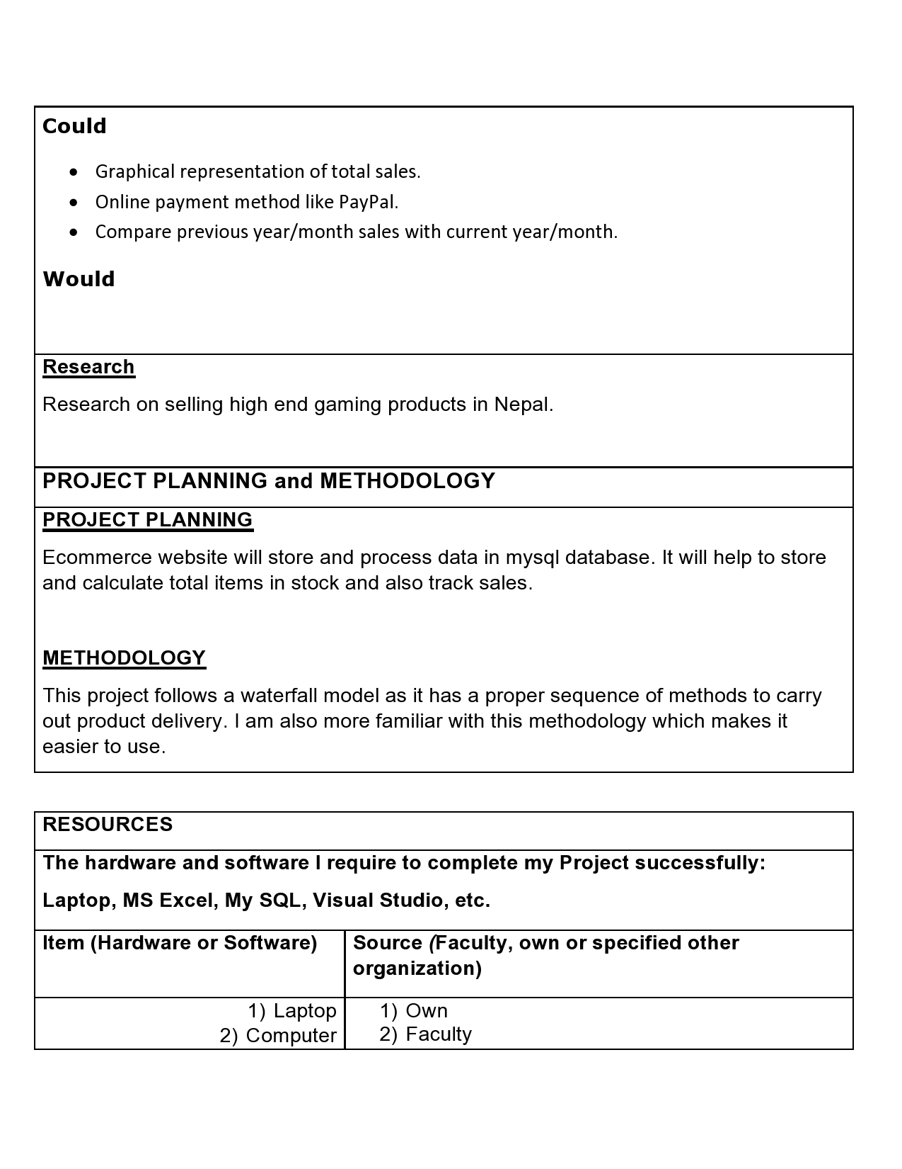

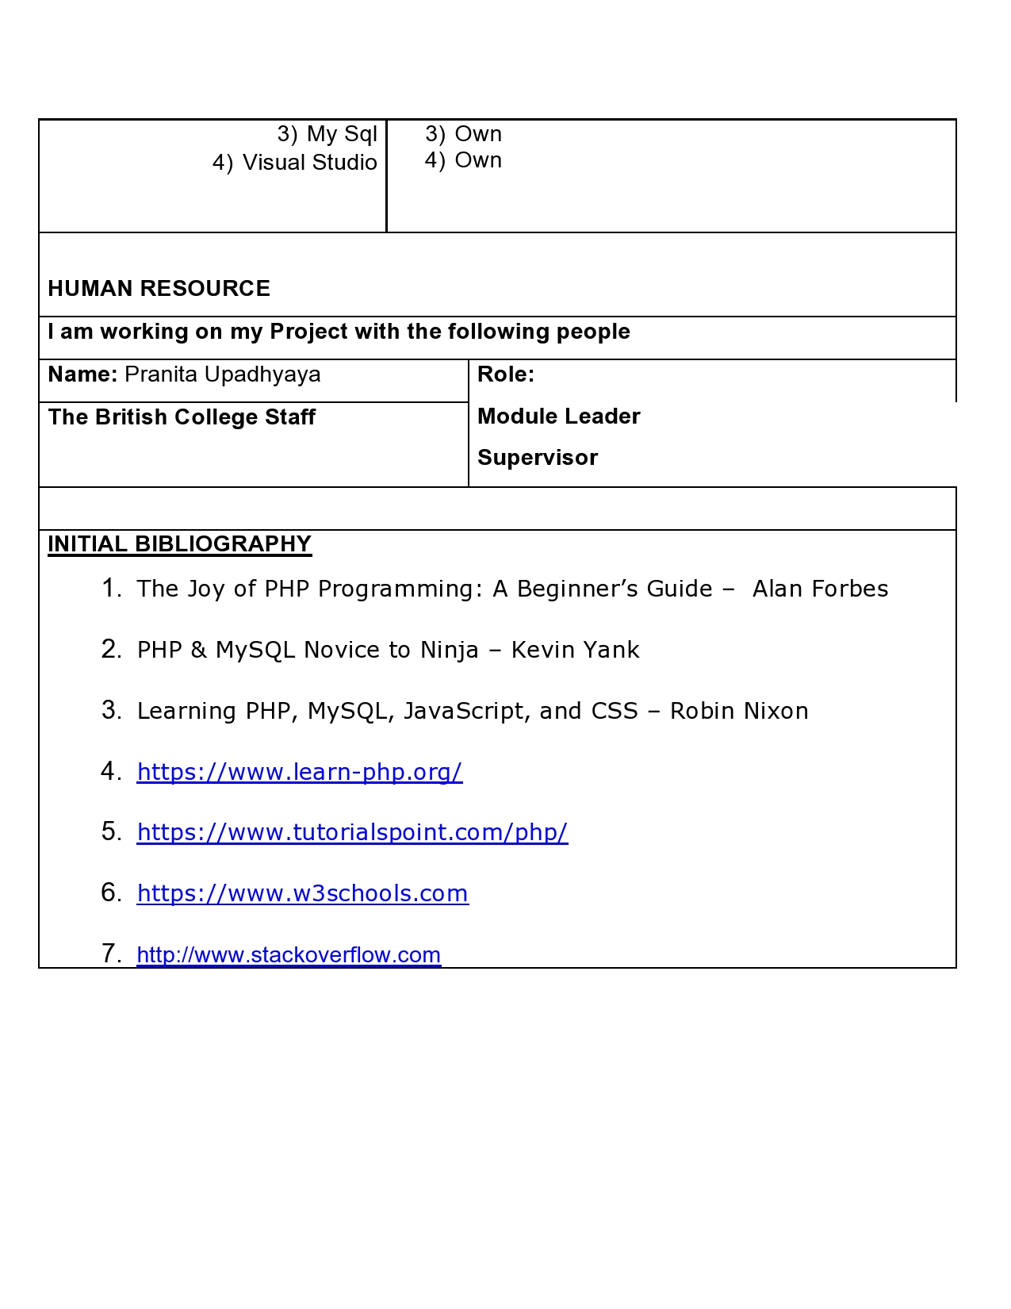

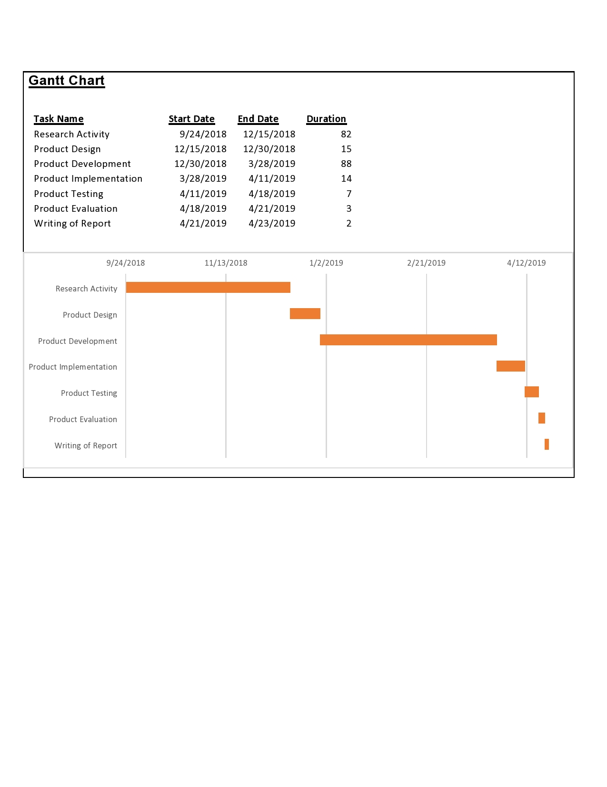

APPENDIX D

LOGIN CREDENTIALS

===========ADMIN LOGIN============

USERNAME: admin@gmail.com

PASSWORD: admin

===================================

===========USER LOGIN==============

USERNAME: user@gmail.com

PASSWORD: user

===================================

USER GUIDE FOR ADMIN MODULE

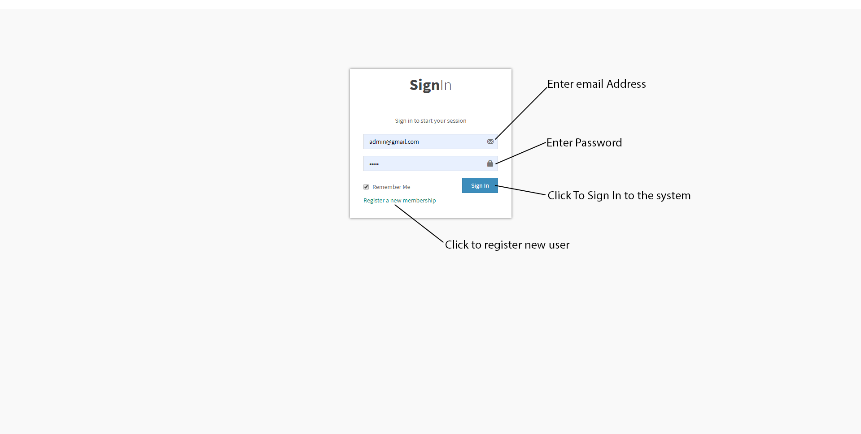

Figure 1: Login Page

After logging in to the system you will be re-directed to the dashboard page.

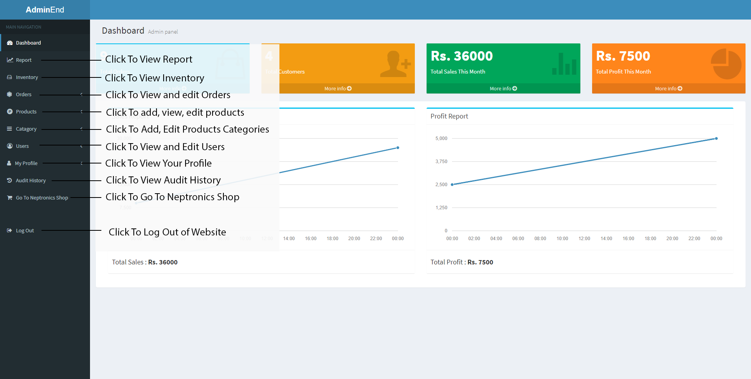Figure 2: Admin’s Dashboard

This is an Admin’s dashboard, you can view anything listed in navigation bar by clicking on it and respective page will open. For Example when you click on Report, sales report page will open and you can see sales and other reports.

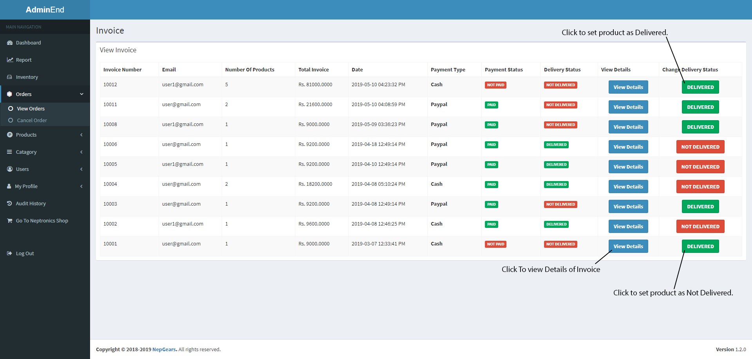Figure 3: View Invoice Page

When you click on view orders tab, this page shows up. Here you can see invoices ordered with newest to oldest. You can also view order details by clicking to view details button. You can change delivery status of a product by clicking delivered and not delivered buttons.

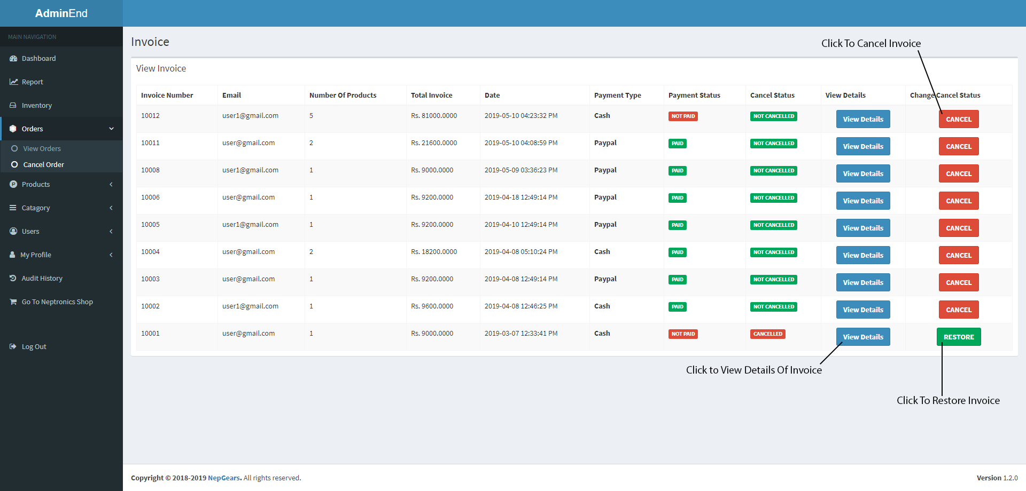Figure 4: Cancel Orders Page

When you click on cancel orders tab, this page shows up. Here also you can see invoices ordered with newest to oldest. You can also view order details by clicking to view details button. You can change invoice status of an invoice by clicking cancel or restore. Cancel button will cancel the order and restore button will re-store order.

Figure 5: Add Products Page 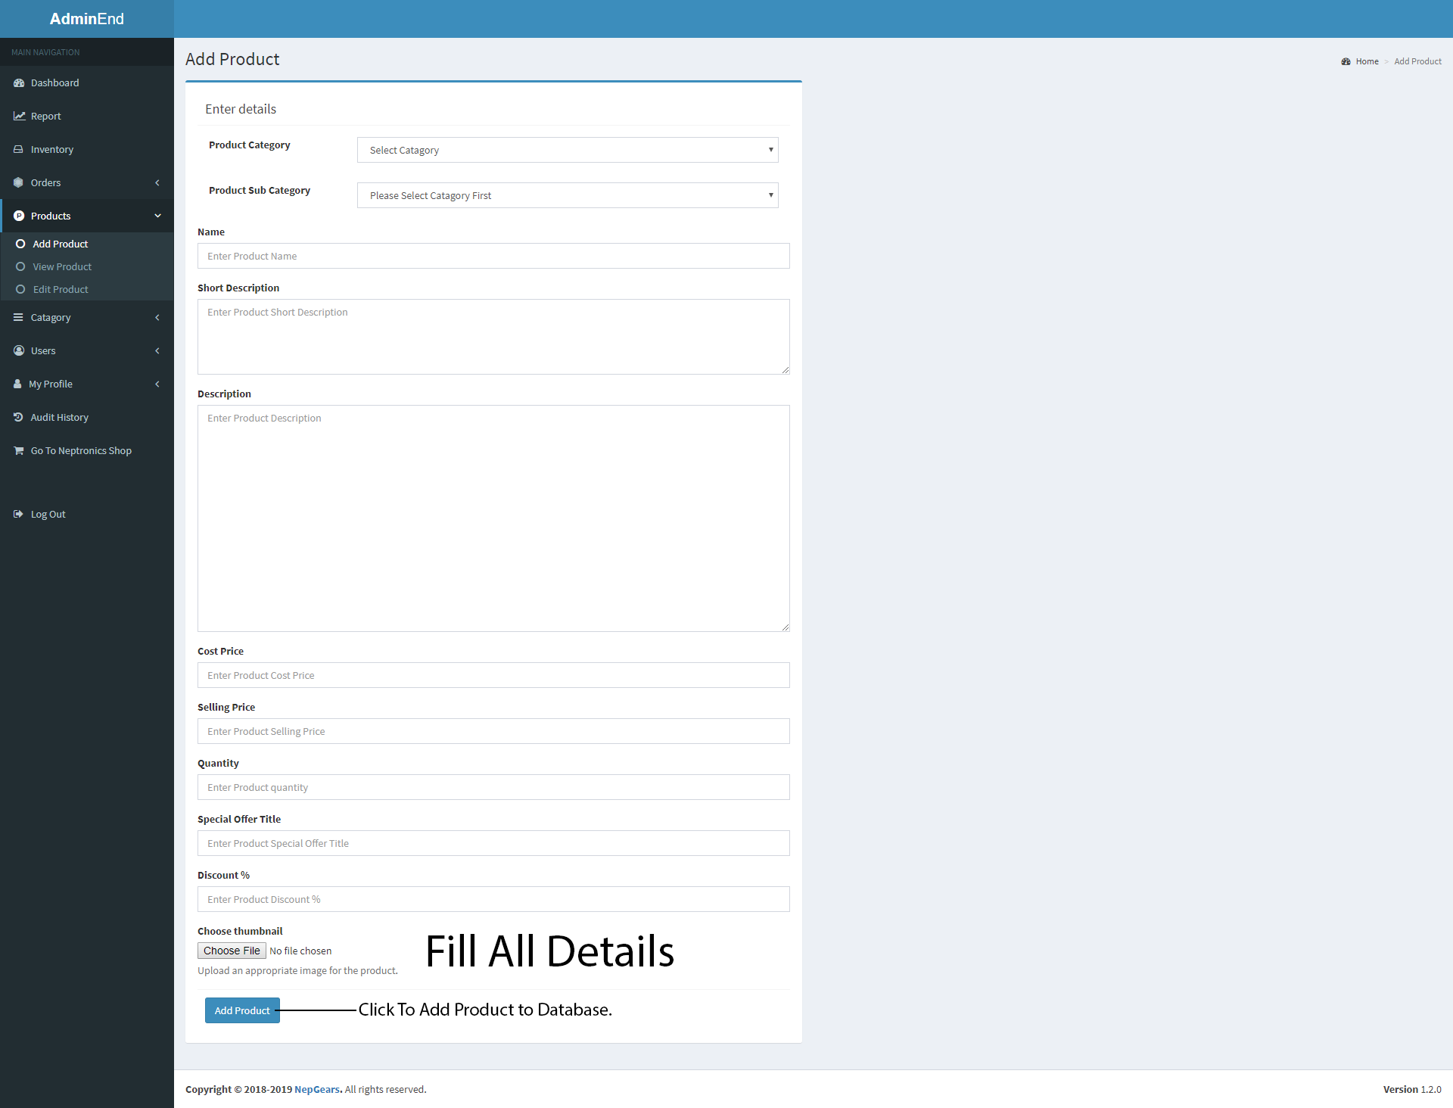

After filling everything required, click on “Add Product” button to add product to database.

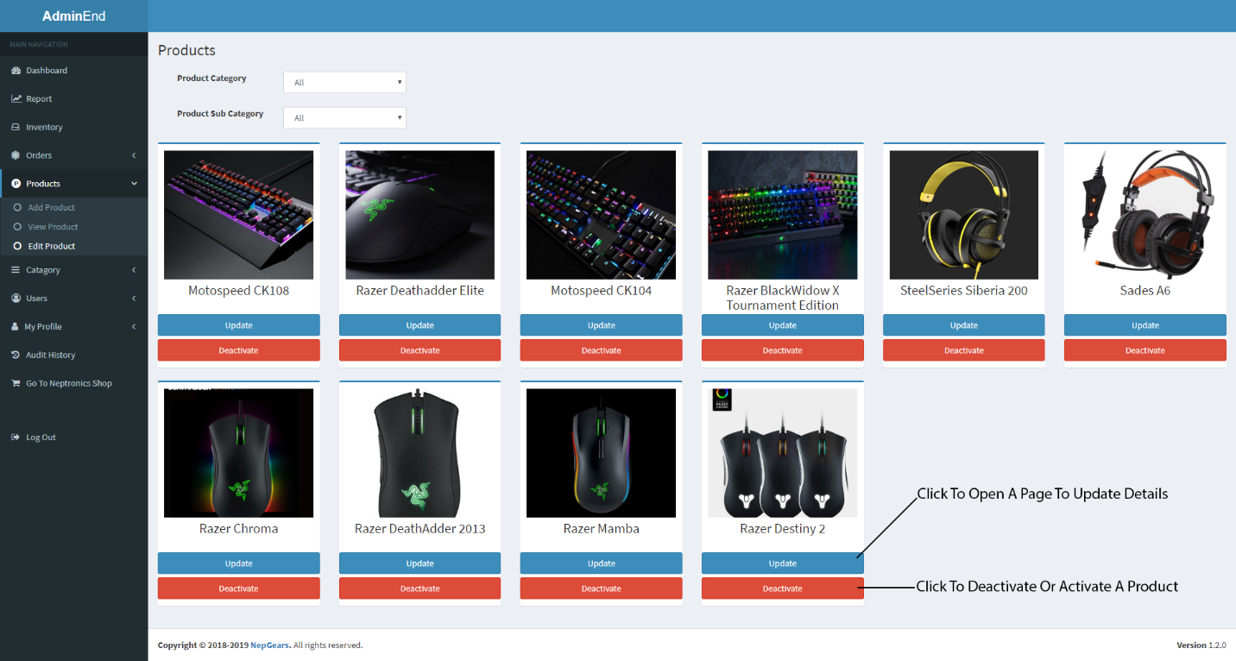Figure 6: Edit Products Page

Choose a product and click update or deactivate product. Deactivate product will deactivate that product and it will not show up in frontend of our website. Whereas, update button will take you to edit product details page.

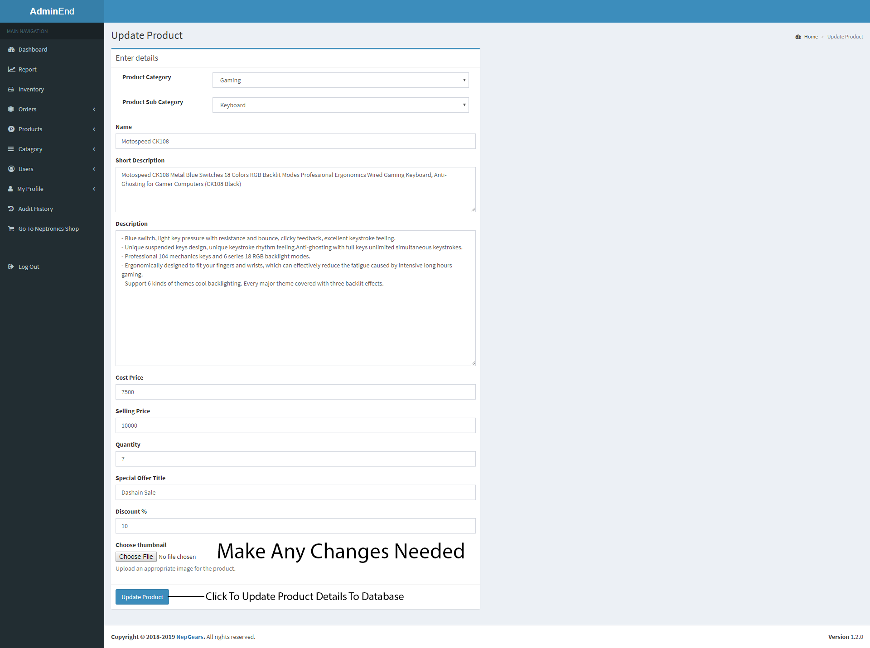Figure 7: Edit Product Details Page

You can make any changes and click on update product button to save changes made.

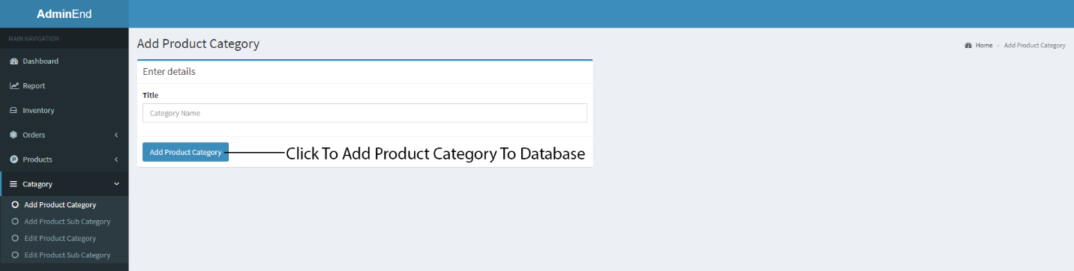

Figure 8: Add Product Category Page

You must fill all the required details required and click on “Add Product Category” button to add product category to database.

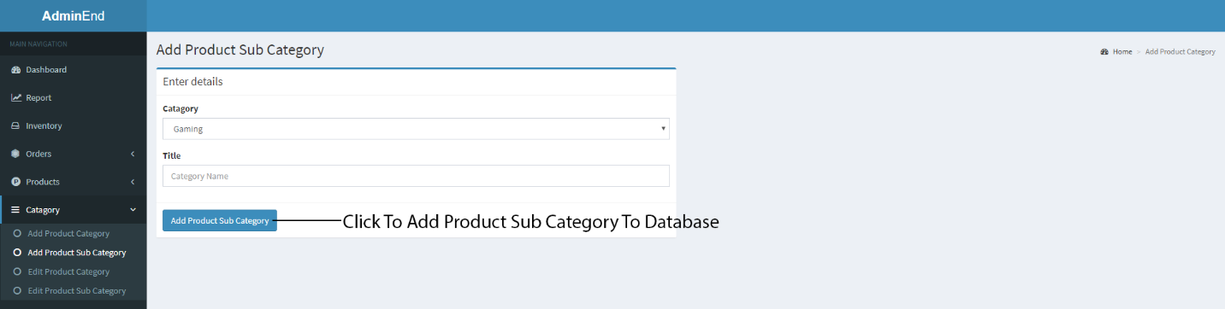Figure 9: Add Product Sub Category Page

You must fill all the required details required and click on “Add Product Sub Category” button to add sub product category to database.

Figure 10: View Product Category Page 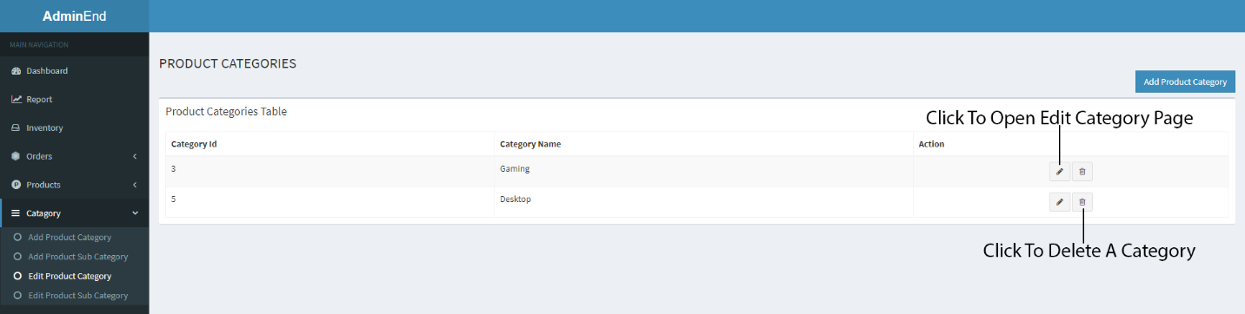

Click on delete button to delete a product category and click on edit button to open a edit category page.

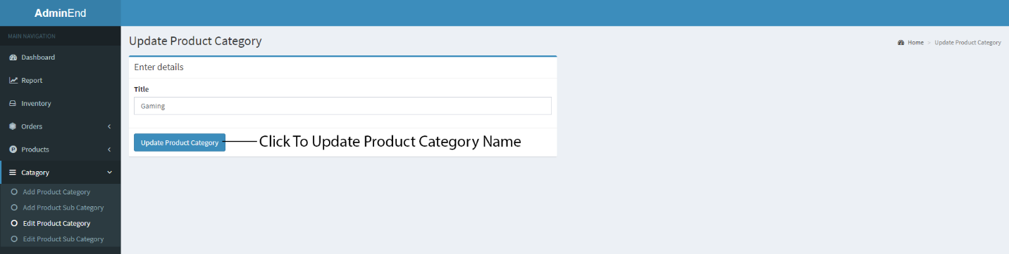

Figure 11: Edit Product Category Page

You can make any changes and click on “Update Product Category” button to save changes made.

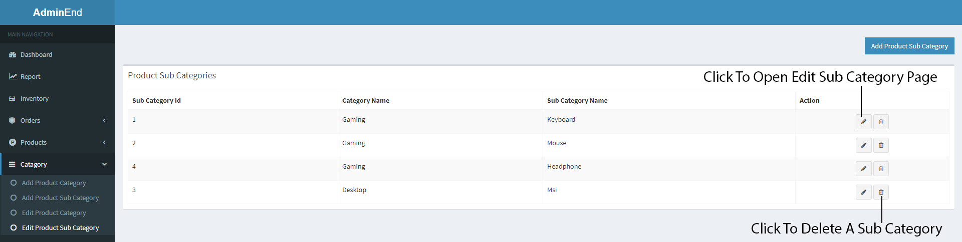Figure 12: View Product Sub Category Page

Click on delete button to delete a product sub category and click on edit button to open a edit sub category page.

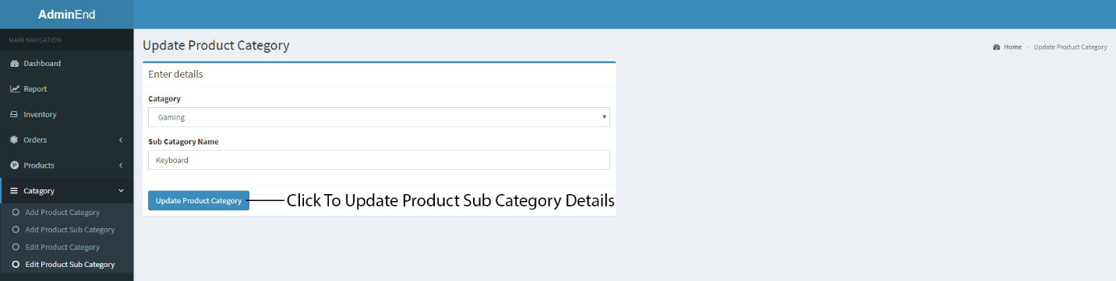

Figure 13: Edit Product Sub Category Page

You can make any changes and click on “Update Product Sub Category” button to save changes made.

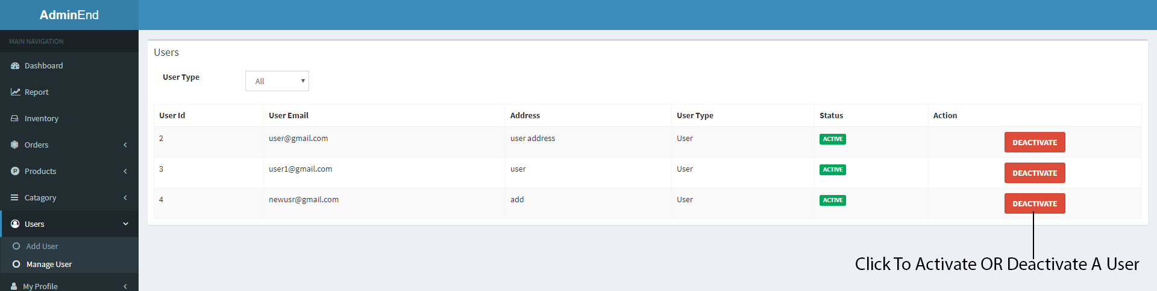

Figure 14: Manage Users Page

You can deactivate or activate user by clicking “Activate” and “Deactivate” buttons respectively.

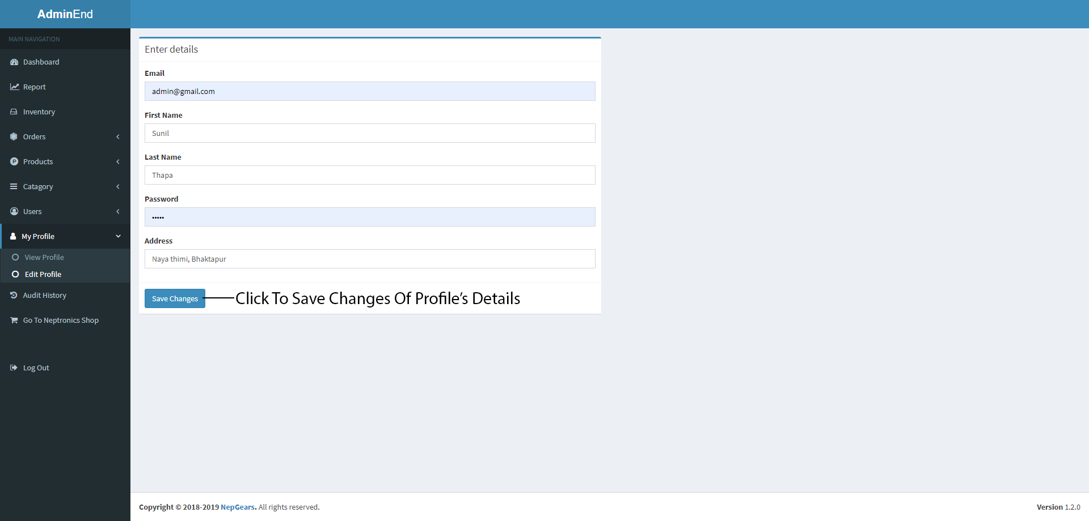Figure 15: Edit Profile Page

You can make any changes and click on “Save Changes” button to save changes made.

Note: Only pages where things can be changed are shown here. However there are pages live inventory, report and so on where you can just view that page and cannot anything are also there but simple to understand. That’s why it’s not present in this guide.

USER GUIDE FOR USER MODULE



Figure 16: Login Page

After logging in to the system you will be re-directed to home page of our website.

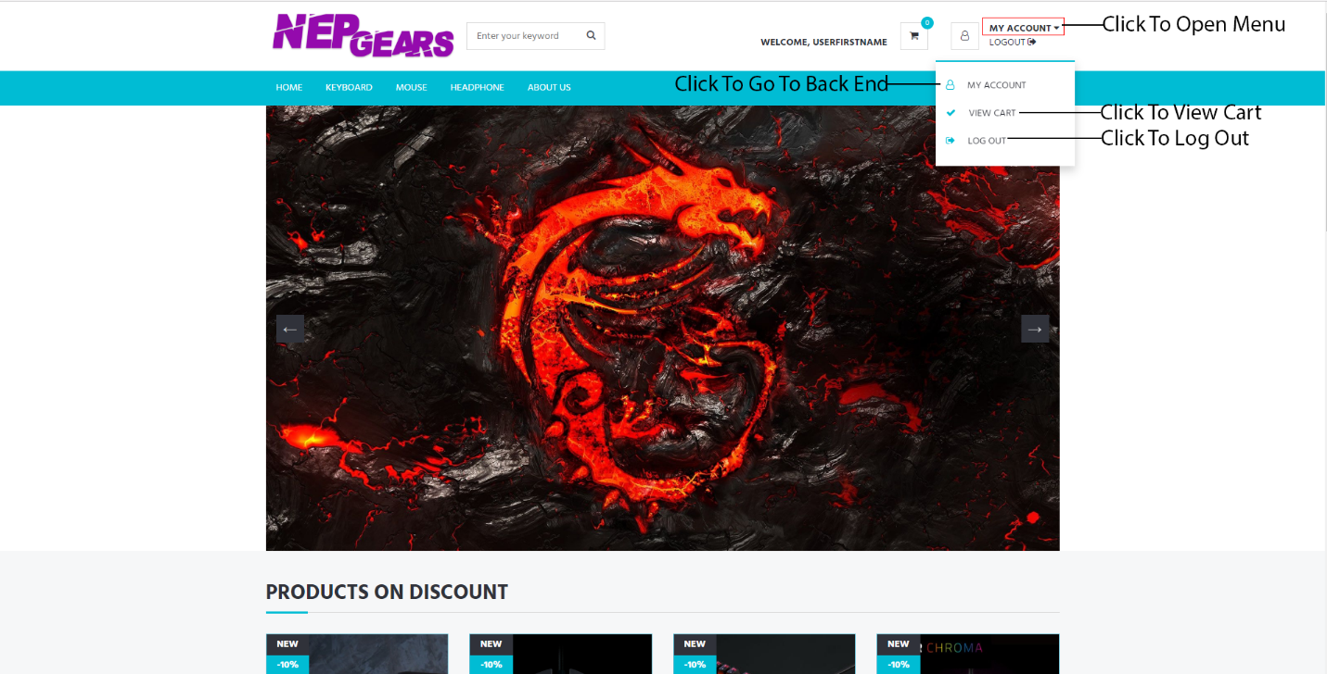

Figure 17: Home/Index Page

This is where you will be redirected to after successful login as a user.

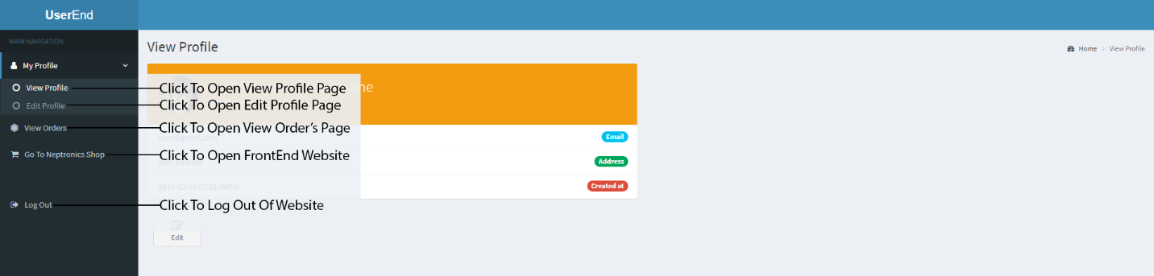Figure 18: User’s View Profile Page

You can view anything listed in navigation bar by clicking on it and respective page will open.

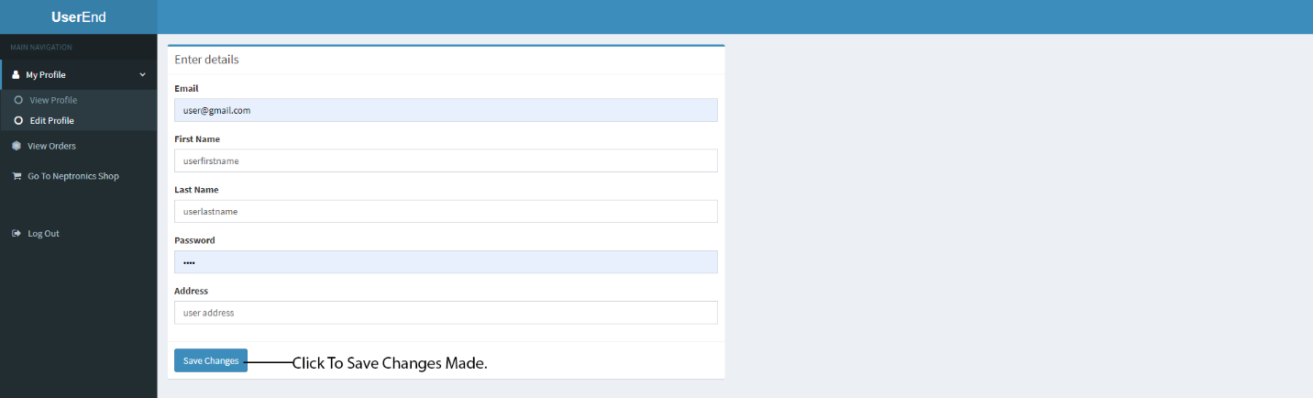

Figure 19: User’s Edit Profile Page

You can make any changes and click on “Save Changes” button to save changes made.

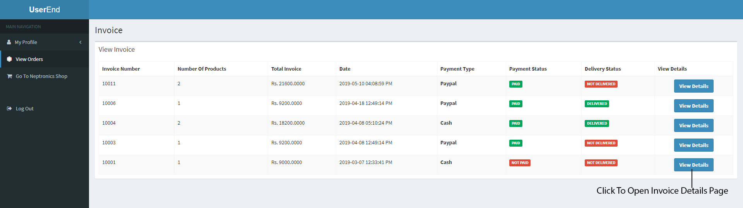

Figure 20: View Invoice Page

When you click on view orders tab, this page shows up. Here you can see invoices ordered with newest to oldest. You can also view order details by clicking to view details button.

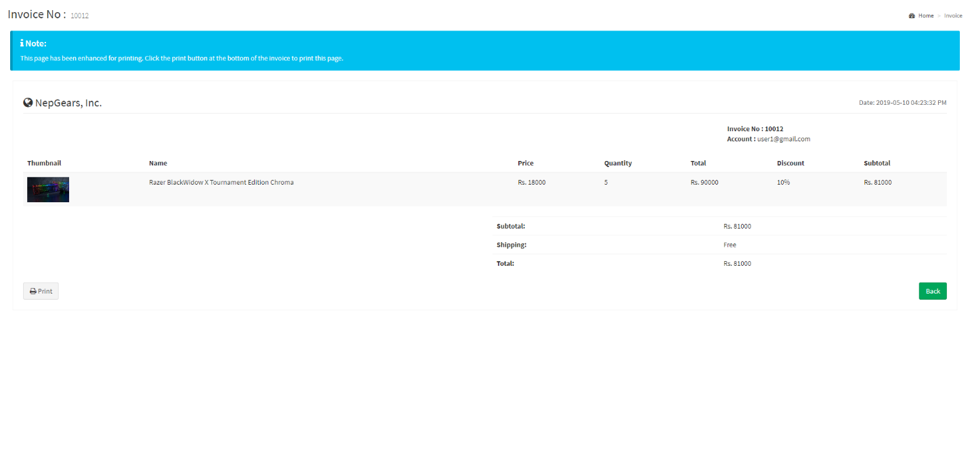Figure 21: Invoice Page

When you click on view details button, this page shows up. Here you can see detail information like products details, total price, and quantity and so on.